Instructions
Currrently registered with Lewisham homesearch but need to create a new password for Lewisham FindYourHome.
Go to Lewisham FindYourHome website www.lewishamfindyourhome.org.uk link and click on ‘Already registered without a password?’
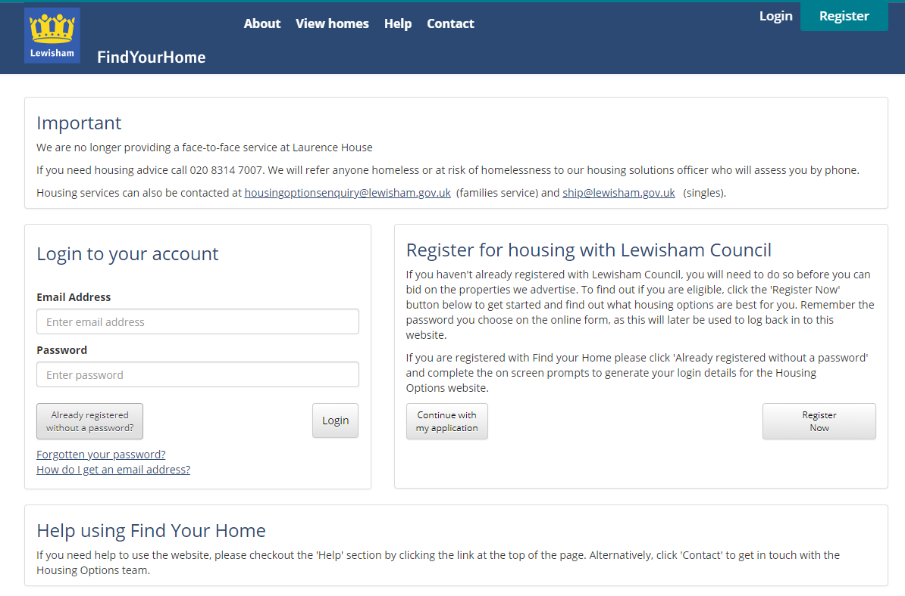

Enter your current Lewisham Homesearch number and date of birth and click ‘continue’. If you do not know your Lewisham Homesearch number contact 0208 31 47007.

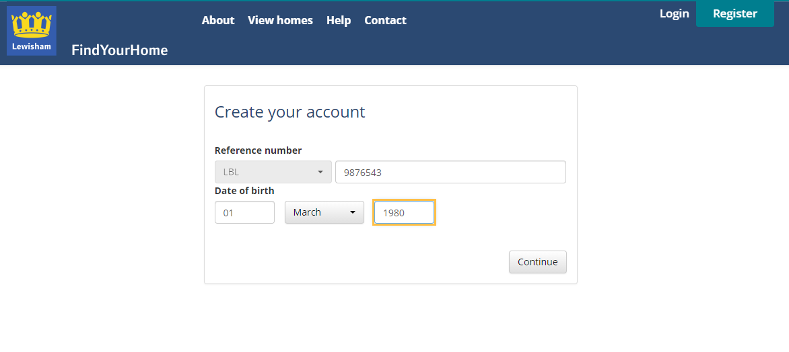
Add an email address (this needs to be an email address you can access, you will need to access it to activate your new password). Click ‘continue’
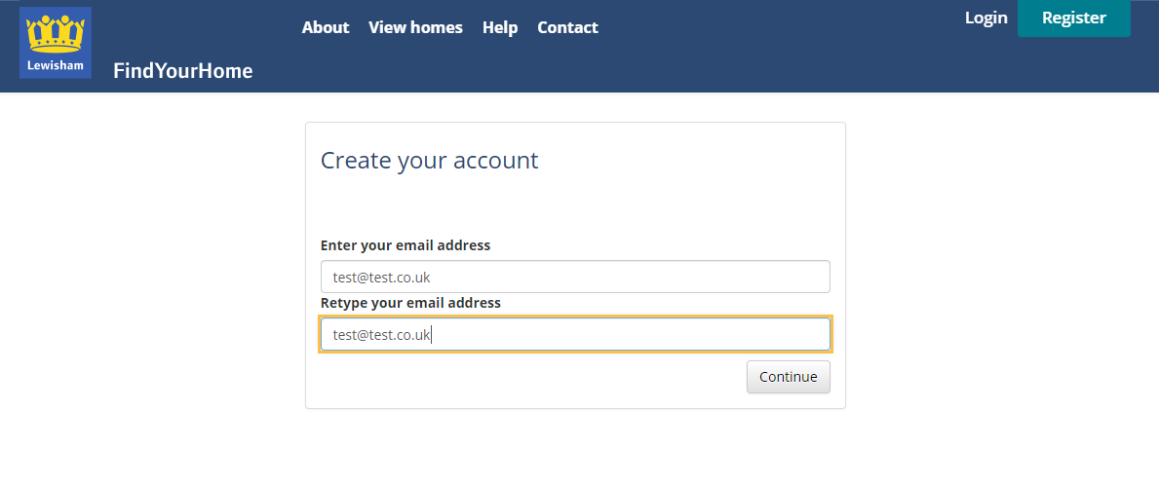
This message will generate and they system will send you an email.
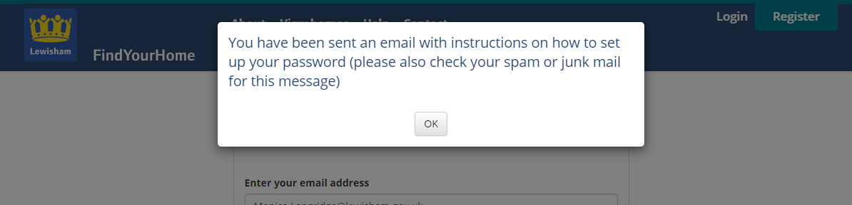

Go to your email and retrieve the email which will look something like this. Click on the link to set your password.
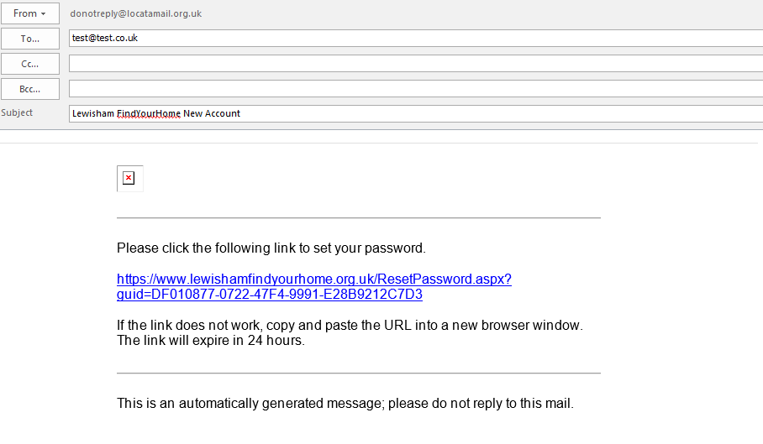
You will be taken back to the Lewisham FindYourHome website where you can then set up a password. Please choose something memorable. You will need to remember this password each time you want to place a bid.
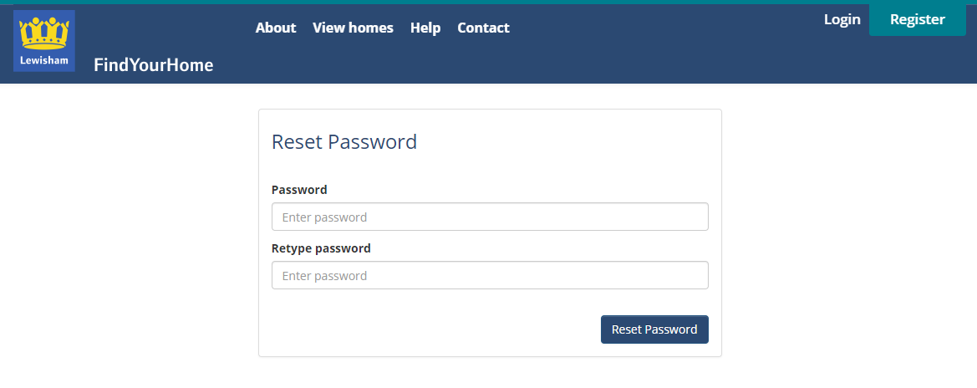
This message will pop up to tell you your password has been reset.
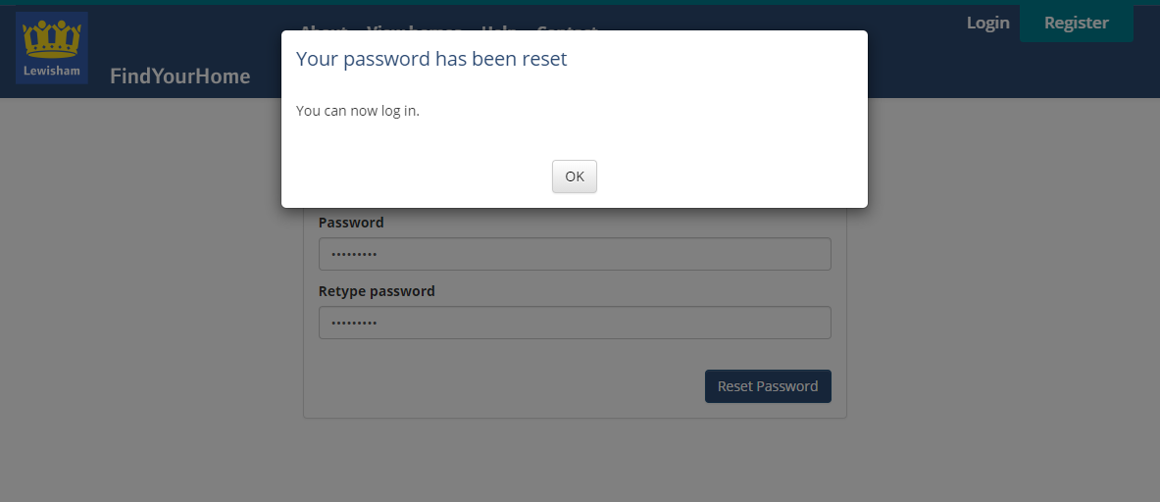
You can then log in to your account on www.lewishamfindyourhome.org.uk link using your email address and the new password you have just created to log in.
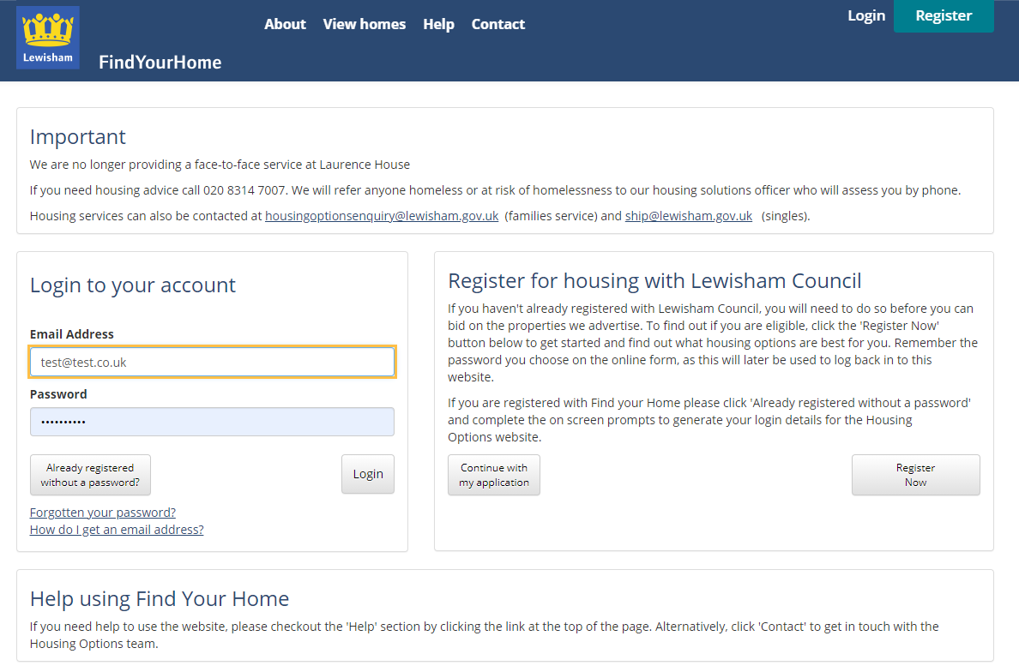
You should now be able to see your account and id on properties you are eligible for.
