 | STANDARDS COMMITTEE
Title | Annual Complaints Report
Key decision | No |  | Item no
Wards | All wards
Contributors | Executive Director for Customer Services
Class | Part 1 | 7th December 2011

- Executive Summary

  - The report provides performance information on complaints dealt with by the Council at stages 1 and 2 of the Corporate Complaints procedure as well as complaints and enquiries to the Mayor and Councillors and complaints and enquiries from MP’s during 2010/11. There were a total of 5,031 complaints and enquiries received in 2010/11, this represents a 24% decrease when compared to 2009/10. The biggest decrease was in the number of Stage 1 complaints. However there was slight increase in the number of Mayor complaints and enquiries which rose by 8% from 538 to 579.

  - The report does not include complaints about the provision of adult and children’s social care both of which are reported and publicised according to statutory guidance.

  - The Independent Adjudicator’s (IA) report is attached at Appendix 1. The IA dealt with 74 complaints between 1 April 2010 and 31 March 2011 of which she partially or fully upheld 40 (56%). The IA responded to 79% within the 30-day response standard, a decrease in performance of 10% against the 2009/10 performance. The IA identified a number of issues from the complaints and makes recommendations for improvement.

  - The IA has also raised a concern that there has been one case in which the Council didn’t follow the advice that supported her recommendations.

  - The Local Government Ombudsman (LGO) report is attached at Appendix 2. In 2010/11, the LGO made decisions in a total of 89 cases, a decrease of 2 cases on the previous year. Lewisham received no public reports.

- Purpose of Report

  - To update the Standards Committee on the Council’s complaints performance for 2010/11 at all stages including the Independent Adjudicator’s report and the Local Government Ombudsman Annual Review.

- Policy Context

  - Lewisham’s Sustainable Community Strategy 2008-2020 contains the shared priorities for the borough. It sets out a framework for improving the quality of life and life chances for all who live in the borough. This approach works towards meeting the ‘Empowered and Responsible’ priority where people take responsibility for the well-being of their area and those who live there. Informing the Council where it has gone wrong or commenting on what it has done right means that local services can respond quickly and effectively.

  - The Council has outlined ten corporate priorities which enables the delivery of the Sustainable Community strategy. Access to the Council's complaints system and the annual review of complaints and enquiries to the Council addresses the 'Community Leadership and Empowerment' corporate priority to develop opportunities for active participation and engagement of people in the life of the community.

- Recommendations

Members are recommended to:

  - Note the contents of the report.

- Introduction

  - This report summarises how the Council and its partners performed when dealing with complaints and how it is using the feedback from complaints to improve services. The report does not cover statutory complaints received for adult and children’s social care that are subject to a separate report.

  - The report includes a summary of the Independent Adjudicator’s report and a summary of the Local Government Ombudsman’s Annual Review with the full reports attached as appendices.

- Stage 1, 2 complaints , MP, Mayor and Councillor enquiries

  - The standard response times and responsibility for responding to complaints at each stage are:

Stage 1 – 10 days by the Service Manager

Stage 2 – 20 days by the Head of Service or Executive Director

Stage 3 – 30 days by the Independent Adjudicator

MP/Mayor/Councillor – 10 days by the Head of Service or Executive Director

  - The tables below show the number of representations the Council and each directorate dealt with in the year and the percentage dealt with in the standard response time. The statistics are for cases logged onto iCasework between 1 April 2010 and 31 March 2011 compared with performance over the same period in 2009/10. This does not include general enquiries to services only those that are received via the Mayor, Members and MPs. Please note, these figures do not include enquiries made by the general public directly to the Council.

 | Total Complaints and Enquiries
Directorate | 2009/10 | 2010/11 | Variance
Children and Young People | 281 | 329 | 48
Community Services | 271 | 319 | 48
Customer Services | 2770 | 2333 | -437
Lewisham Homes | 2063 | 1325 | -738
Regeneration | 1200 | 700 | -500
Resources | 37 | 25 | -12
Total | 6622 | 5031 | -1591

 | Stage 1 |  |  | Stage 2
Directorate | 2009/10 | 2010/11 | Variance | 2009/10 | 2010/11 | Variance
CYP | 66 | 64 | -2 | 6 | 9 | 3
Community Services | 81 | 83 | 2 | 4 | 6 | 2
Customer Services | 1103 | 895 | -208 | 163 | 170 | 7
Lewisham Homes | 978 | 572 | -406 | 199 | 118 | -81
Regeneration | 174 | 149 | -25 | 28 | 34 | 6
Resources | 21 | 10 | -11 | 1 | 1 | 0
Total | 2423 | 1773 | -650 | 401 | 338 | -63

 | MP |  |  | Mayor |  |  | Members
Directorate | 2009/10 | 2010/11 | Variance | 2009/10 | 2010/11 | Variance | 2009/10 | 2010/11 | Variance
CYP | 123 | 143 | 20 | 19 | 42 | 23 | 67 | 71 | 4
Community Services | 83 | 73 | -10 | 32 | 47 | 15 | 71 | 110 | 39
Customer Services | 694 | 540 | -154 | 206 | 257 | 51 | 604 | 471 | -133
Lewisham Homes | 443 | 336 | -107 | 91 | 100 | 9 | 352 | 199 | -153
Regeneration | 168 | 136 | -32 | 186 | 130 | -56 | 644 | 251 | -393
Resources | 3 | 3 | 0 | 4 | 3 | -1 | 8 | 8 | 0
Total | 1514 | 1231 | -283 | 538 | 579 | 41 | 1746 | 1110 | -636

  - The number of complaints and enquiries received in 2010/11 was 5031. This was a significant decrease (24%) on the previous year when a total of 6662 were received. This reflects the impact of decisions and consultations which took place in 2009/10, for example that year Regeneration received a significantly higher number of complaints and enquiries due to the introduction of new Controlled Parking Zones (CPZs) and consultation on Lewisham Town Centre.

  - Overall the number of Stage 1 and Stage 2 complaints has continued to decrease however there was an increase in the number of enquiries received by the Mayor which rose by 41 from 538 in 2009/10 to 579 in 2010/11.

  - Lewisham Homes have worked to reduce the number of complaints received at Stage 1 by effectively dealing with cases earlier through the introduction of an informal stage and also reviewed the escalation process to ensure that wherever possible all complaints are investigated at Stage 1 instead of being escalated to Stage 2 from another enquiry – to councillors, the Mayor, MP or via the Local Government Ombudsman.

The chart below shows the trend in performance by stage over the last three years.

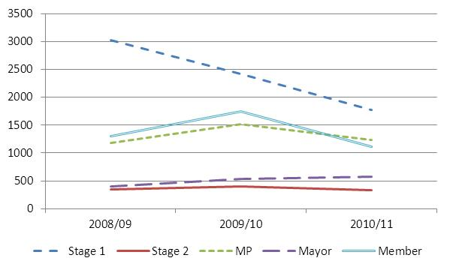

  - The distribution of complaints received by Ward is shown on the map below. This shows that the highest number of complaints received per 1,000 population was received from residents in Ladywell Ward.

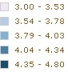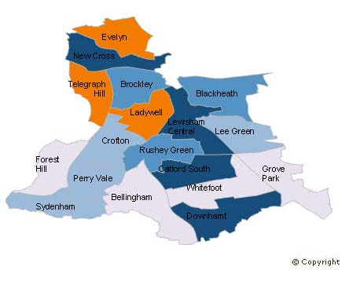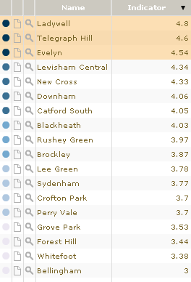

  - As in previous years overall the largest proportion of complaints received relate to council tax and housing management. A table at Appendix 3 sets out the top 3 types of complaint by Ward as this does vary across the borough.

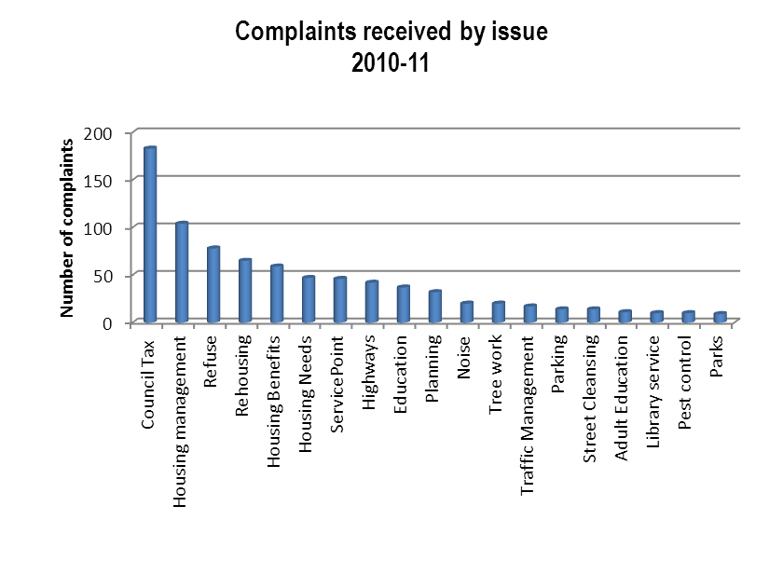

  - The reason for the complaint also varies across the directorates. The table below shows the top areas by directorate, excluding Resources who do not have sufficient complaints to establish trends. The main reasons for complaints were:

- Service not provided or not of expected standard
- Disagree with decision
- Failure to take/complete action

CYP | Community Services | Customer Services | Regeneration | Lewisham Homes
Primary Schools: Education Access | Community Education Service: Curriculum team | Rehousing: Development | Highways: Street Works | Maintenance service: responsive repairs
Secondary School and Colleges: Education Access | Sport and Leisure: Contractor | Council Tax: Bailiff action | Development Control: Planning Applications | Plumbing: responsive repairs
SEN provision | Crime Reduction Service: Anti-social Behaviour | Council Tax: Summons | Parking enforcement | Technical team; inspections

Complaints and service improvement

  - Each directorate has responsibility for managing complaints and this process is overseen by the Corporate Complaints team. Directorate representatives meet regularly to raise and resolve common issues and exchange best practice. Throughout the year directorates have worked to improve the quality of the complaints handling. Actions include:

- Offering on the spot resolution to avoid complaints escalating
- Scanning all documents onto iCasework to enable a complete view of the investigation to be available to others
- Introduction of a response template at stage 2 to gather information and ensure all aspects of a customers complaint have been addressed
- Introduction of an informal complaints stage by Lewisham Homes prior to Stage 1.

  - As well as ensuring that the complaints process is as efficient and effective as possible, utilising the complaints received to inform and drive service improvement is seen as a key function for those dealing with complaints.

  - Each directorate has used complaints received to identify areas of concern and make changes to improve the way the service is delivered.

For example:

- CYP are developing a more robust monitoring system to ensure that formal Statement of Special Educational Need (SEN) review meetings take place when scheduled

- Concerns raised by a customer have informed the way in which the Council communicates with service users about Direct Payments and individual Budgets

- Planning are reviewing their enforcement processes to ensure that where actions have been agreed they are monitored

- In response to the number of complaints received about repairs Lewisham Homes have revised their procedures to minimise delays and achieve more ‘first fix’ repairs.

  - More detailed information on the actions undertaken by directorates to improve the quality of complaints handling and the lessons learnt are set out in Appendix 4.

- Independent Adjudicator

  - The Independent Adjudicator (IA) deals with stage 3 complaints on behalf of the Council. This section summarises the IA’s report and the action being taken in response to the issues raised. The report covers the period 1 April 2010 to 31 March 2011, but does include one case resolved in 2011/12 where the IA has raised concerns that her recommendations were not implemented.

  - The IA dealt with 72 cases (2 cases were withdrawn) and upheld, in full or part, 40 cases. This is a 28% decrease in the number received in 2009/10. The percentage of cases partially or fully upheld remained the same at 56%.

  - The IA has commented positively in her report on the fact that only a small percentage of Stage 1 complaints (3.5%) progress to Stage 3. In addition the percentage moving from Stage 2 to Stage 3, which was raised as a concern in the 2010 report, has decreased from 25% to 22%. She also felt that Lewisham’s complaints process is clear and accessible and therefore does not see the decrease in numbers being the result of poor signposting.

  - The IA responded to 79% of cases within the 30 day standard, below the 85% target. This was mainly due to the complexity of the cases and in all instances complainants were notified of the delay.

  - Cases by directorate

The table below sets out the number of Stage 3 complaints against each directorate and each partner (withdrawn cases in brackets). Though the number of Stage 3 complaints decreased overall there was an increase in Regeneration where the number increased from 5 to 9. This was mainly due to the increase in the number of planning complaints which increased from 3 to 5.

Directorate | 2009/10 | 2010/11
Children and Young People | 1 | 2
Community Services | 2 | 2
Customer Services | 44 (2) | 22 (1)
Lewisham Homes | 41 (2) | 31
Regenter B3 | 6 | 7
Regeneration | 5 | 9
Resources | 1 | 1
Total | 100 (4) | 74 (1)
Note: 1 case received in 2010/11 was withdrawn after 1st April 2011

  - Compensation

Compensation was awarded in 27 cases ranging from £50 to £4,000. The total amount of compensation paid was £11,559. This compares to 26 cases in 2009/10 with the total amount being £8,745.

 | Up to and including £100 |  | £100-£500 |  | More than £500 |  | TOTAL
2009/10 | 12 | £1,025 | 13 | £4,350 | 2 | £2,785 | 27 | £8,159
2010/11 | 5 | £400 | 19 | £4,945 | 2 | £6,250 | 26 | £11,559

  - Key issues highlighted by the IA

  - Compliance
In previous years the IA has been happy with the compliance with her recommendations. However this year she comments that for the first time the Council has failed to implement her recommendations. Though the resolution of this case falls into 2010/11 it has been raised in this year’s report as under the IA protocol instances of non-compliance are to be reported in the annual report.

  - The outgoing IA partially upheld a complaint that related to properties that were identified as empty and recommended that an apology was sent to the complainant and that compensation of £500 was paid. In addition, the IA asked the Council to review its Empty Dwelling Management Order (EDMO) procedure and ensure that it follows the good practice guidance available on the Empty Homes website at www.emptyhomes.com/usefulresources/edmos.html. Also to review its website information on empty homes to ensure that it is balanced and fair.

  - The Council did make an apology and award £500 compensation. The IA’s concerns relate to the fact that the monies owed for building control fees were deducted from the compensation and conflating this issue in the apology letter was not helpful.

  - Timeliness of information
Though the IA states that there has been improvements in the timeliness of the information submitted she is concerned that the case file notes or a case file analysis is not consistently provided. This is an issue that has been highlighted in previous years but still causes concern. The difficulty for the IA is that it is often only once the investigation has begun that it becomes clear what evidence is missing and this can result in a delay in responding.

  - Apologies
A well-drafted and genuine apology can go a long way to reassuring a complainant that their concerns have been taken seriously. The IA raises concerns about the standard of apologies that are being sent to complainants and recommends that the guidance on producing these is reviewed as where reluctance is conveyed in poor wording in an apology, this can exacerbate the issue.

  - The IA’s report for the Council is attached at Appendix 1. The IA has prepared a separate annual report for Lewisham Homes which deals specifically with any issues relating to them. The IA will attend their management team to present the report and the Council will monitor any actions arising from it.

- Local Government Ombudsman Annual Letter 2010/11

  - The Local Government Ombudsman (LGO) produces an annual review for all councils. The review provides statistics on complaints received over the past year by the Ombudsman against local authorities. This year’s annual review letter is an overview of the work of the LGO and does not include any commentary specific to Lewisham cases. The Local Government Ombudsman’s Annual Letter is attached at Appendix 2.

  - Enquiries received from the Ombudsman are managed, on behalf of the Chief Executive, by the head of his office. During 2010/11 the powers of the LGO were extended to include complaints about independent providers of adult social care received from individual’s funding their own care services.

  - For the year ended 31 March 2011, the LGO made decisions in a total of 89 cases. This is a decrease of 2 from the 91 cases in the previous year. It does not include 2 adult social care decisions made after 1st October 2010. (Adult social care complaints were not included in the 2009/10 figures). There were no public reports issues for 2010/11.

  - When compared with neighbouring authorities Lewisham was the only one which had a decrease in the number of complaints investigated by the LGO. Comparative performance with our neighbours is set out in Appendix 5.

  - The improvement in the Council’s response time to Ombudsman enquiries was sustained in this year with the average number of days to responding decreasing from 31.2 days in 2009/10 to 24.7 in 2010/11.

  - The LGO’s report has been considered at Executive Management Team and cascaded to directorate management teams. The Council continues to build and develop a positive professional relationship with the York Ombudsman’s office, as well as continuing to learn from mistakes made in complaints management.

- Actions for 2011/12

  - An Internal Audit of Comments, Complaints & Compliments which commenced in 2010/11 but reported in 2011/12 gave the service a substantial level of assurance. The recommendations resulting from the audit, all of which were low or medium priority, have been incorporated into the Corporate Complaints Action Plan 2011/12 which is attached at Appendix 6.

  - The Corporate Complaints team and the Corporate Complaints Improvement Group (CCIG) have identified actions to take forward in 2011/12 to ensure that complaints handling across the Council continues to improve. These include:

- Ensuring that the actions resulting from the IA’s recommendations, recommendations relating to last year’s annual report from the Public Accounts Committee and recommendations from an Internal Audit that took place April 2011 are monitored and reviewed regularly by CCIG

- Preparing for the transfer of housing management complaints to the Housing Ombudsman in 2013 and working with housing partners to ensure that this is communicated to tenants

- Working with the LGO to develop training on complaints handling for frontline staff

- IA actions for 2011/12

  - The IA’s role is not only to determine complaints and encourage the Council to learn from those complaints, it is also to make recommendations for good administrative practice. So, this year, the IA will be producing updated guidance on remedies and making apologies. In addition, the IA will be writing a factsheet for complainants to be posted on the Council’s website explaining her role; what she can and cannot look at; the kinds of remedies she proposes; and anonomised examples of complaints she has upheld and not upheld. The IA believes that this will help manage complainant’s expectations at a time when the Council is facing such significant challenges and the consequent prospect of increasing complaints.

- Legal Implications

  - There are no specific legal implications arising from this report. It is recommended good practice from the Local Government’s Ombudsman’s Office to make full and specific reference to handling complaints within a management agreement entered into under section 27 of the Housing Act 1985.

- Financial Implications

  - There are no financial implications arising from this report.

- Personnel Implications

  - There are no personnel implications arising from this report.

- Crime and Disorder Implications

  - There are no crime and disorder implications arising from this report.

- Equalities Implications

  - The iCasework system enables the Council to collect equalities monitoring information which is used to ensure the complaints process remains accessible and that no particular parts of the community suffer inequity in service delivery.

  - The Equality Act 2010 (the Act) brings together all previous equality legislation in England, Scotland and Wales. The Act includes a new public sector equality duty (the equality duty or the duty), replacing the separate duties relating to race, disability and gender equality. The duty came into force on 6 April 2011. The new duty covers the following nine protected characteristics: age, disability, gender reassignment, marriage and civil partnership, pregnancy and maternity, race, religion or belief, sex and sexual orientation.

  - In summary, the Council must, in the exercise of its functions, have due regard to the need to:

• eliminate unlawful discrimination, harassment and victimisation and other conduct prohibited by the Act.
• advance equality of opportunity between people who share a protected characteristic and those who do not.
• foster good relations between people who share a protected characteristic and those who do not.

  - As was the case for the original separate duties, the new duty continues to be a “have regard duty”, and the weight to be attached to it is a matter for the Mayor, bearing in mind the issues of relevance and proportionality. It is not an absolute requirement to eliminate unlawful discrimination, advance equality of opportunity or foster good relations.

  - The Equality and Human Rights Commission issued guides in January 2011 providing an overview of the new equality duty, including the general equality duty, the specific duties and who they apply to. The guides cover what public authorities should do to meet the duty. This includes steps that are legally required, as well as recommended actions. The guides were based on the then draft specific duties so are no longer fully up-to-date, although regard may still be had to them until the revised guides are produced. The guides do not have legal standing unlike the statutory Code of Practice on the public sector equality duty, However, that Code is not due to be published until April 2012. The guides can be found at: http://www.equalityhumanrights.com/advice-and-guidance/public-sector-duties/new-public-sector-equality-duty-guidance/.

  - The corporate complaints and quality team will continue to work with voluntary
community groups to ensure no one is disadvantaged from using the complaints process.

- Environmental Implications
  - There are no environmental implications arising from this report.

- Conclusions

  - The Council has been continually improving its complaints process in response to feedback and best practice. However, there is still a lot more to do to ensure customers receive excellent services. The actions contained in the report will ensure excellence is achieved.

- Background Documents and Report Author

  - There are no background documents to this report.

  - If you would like more information on this report please contact Peter Gadsdon, Head of Strategy & Performance on 0208 314 8464.

Appendix 2

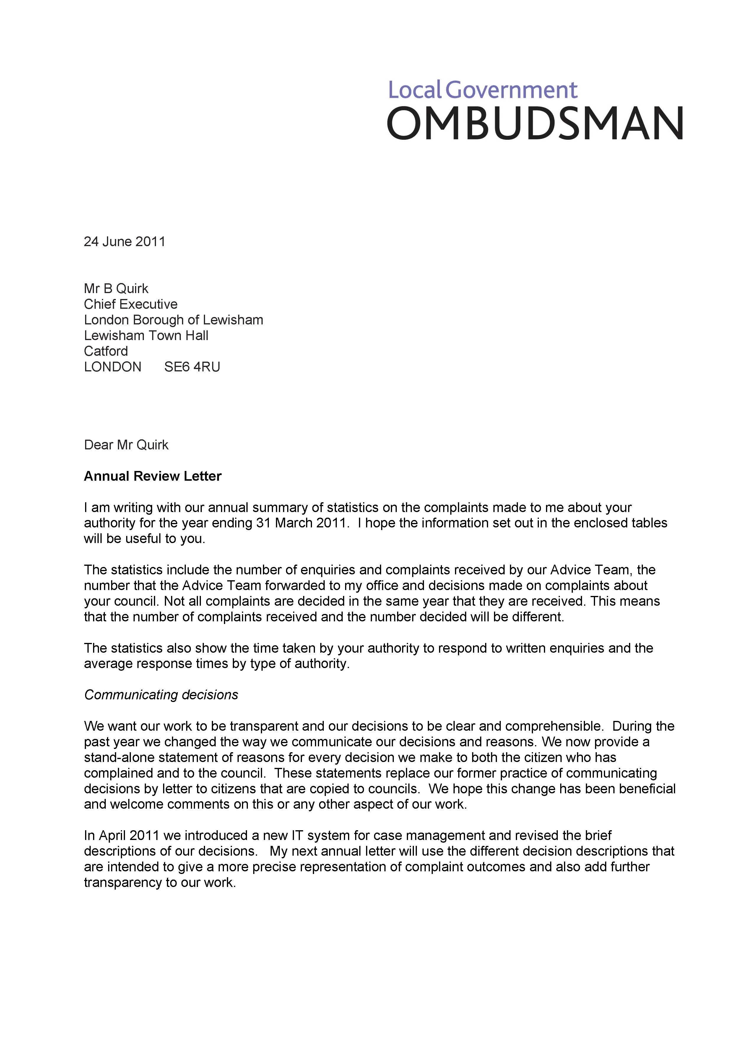

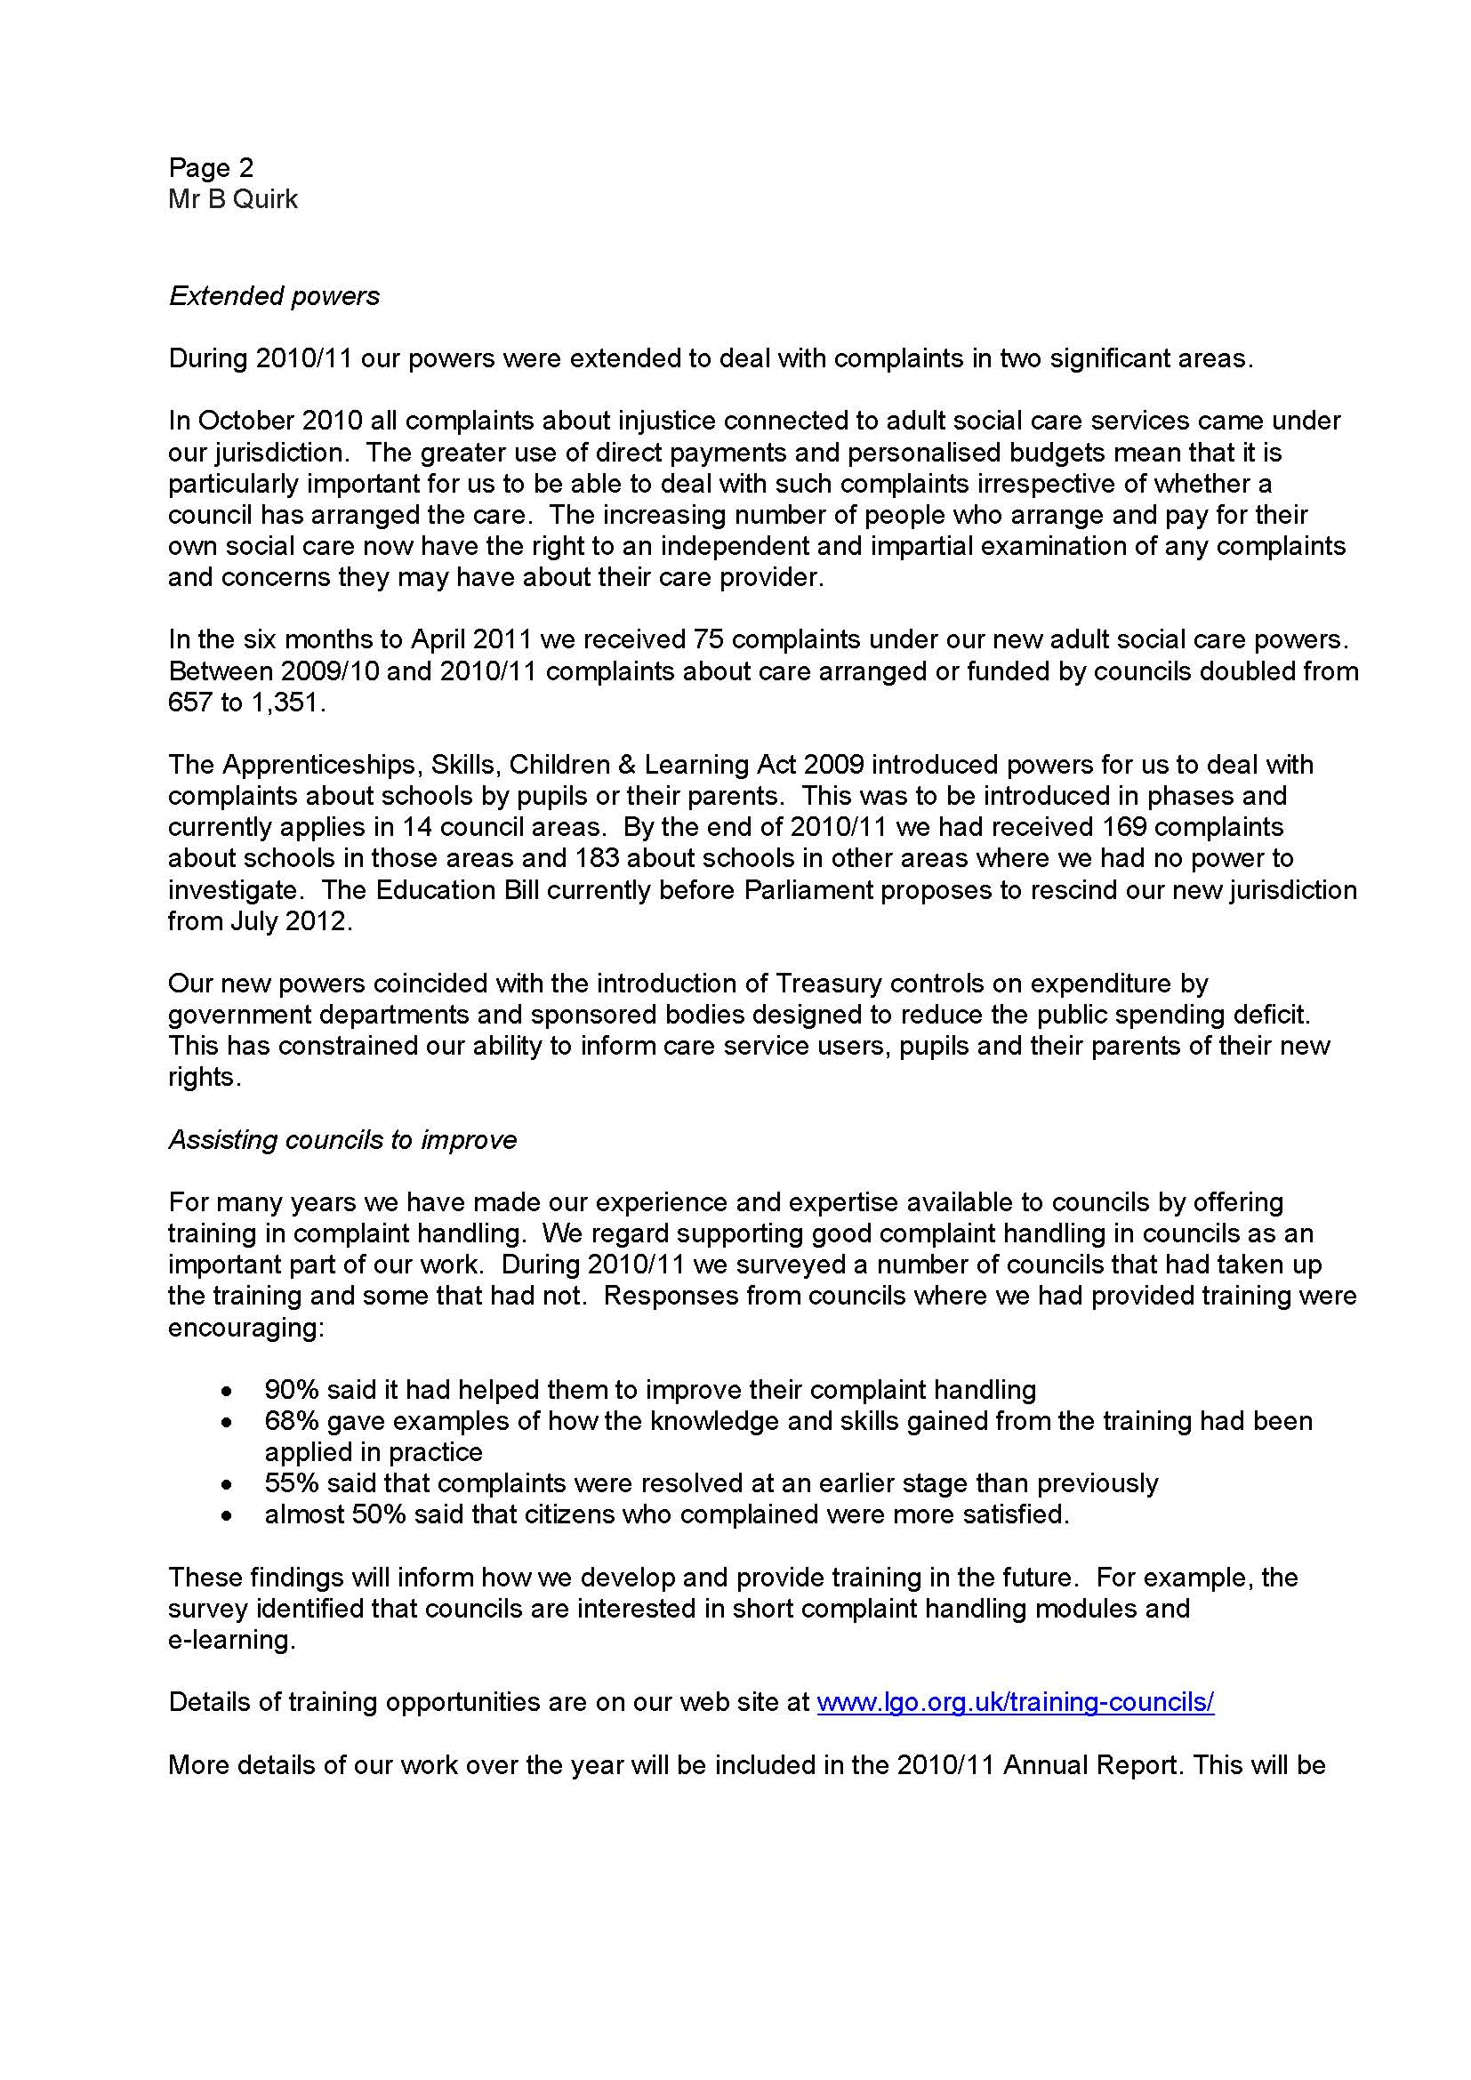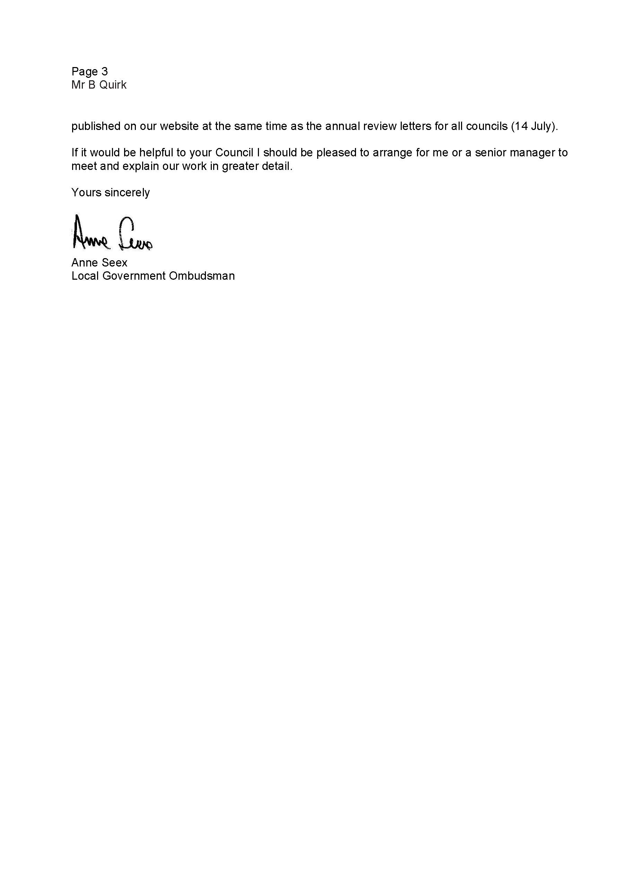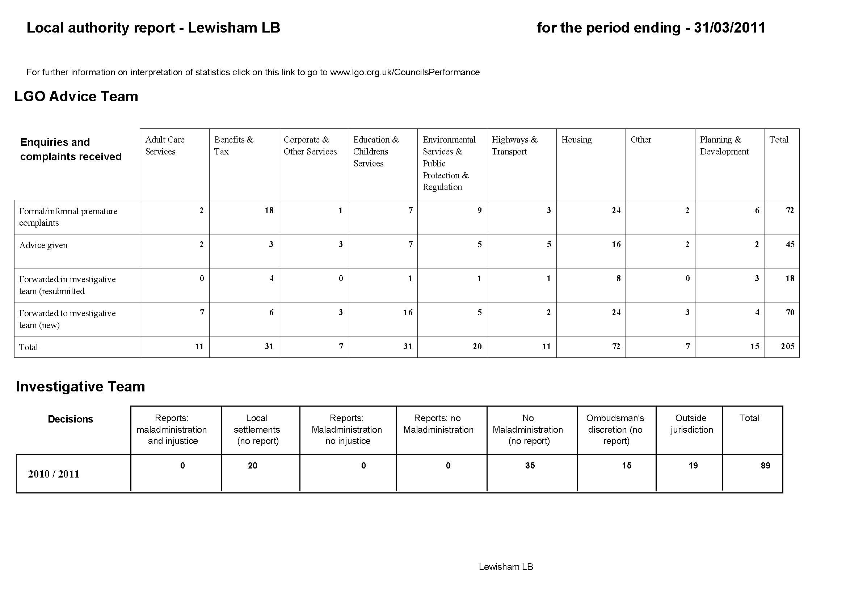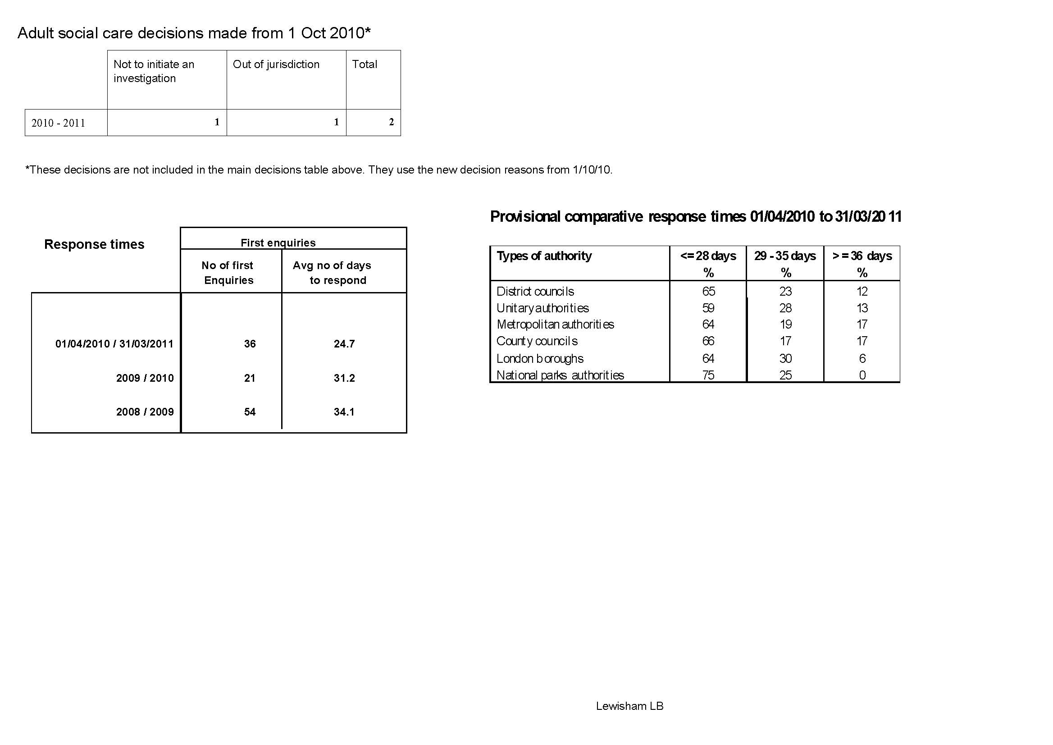
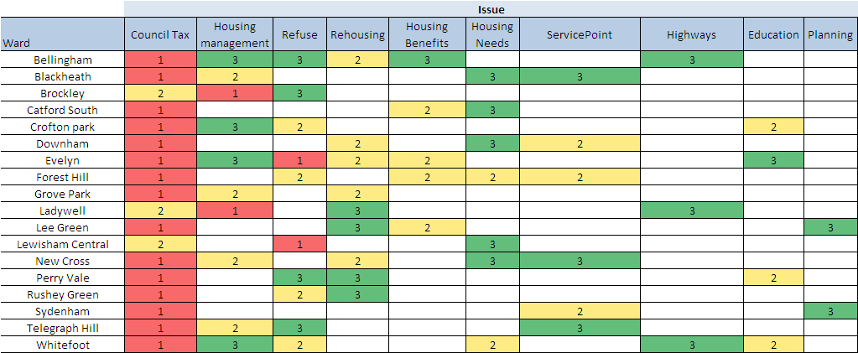

* Based on the post code of the complainant
Appendix 4
Directorate Achievements 2010-11

- Things that have been put in place to improve the quality of complaints handling

CYP

- We offer on the spot resolutions to avoid a complaint from escalating wherever possible, as this is good for the customer as well as the service.
- We have developed a service culture where we value complaints and recognise the importance of managing them well.

Community Services

- In September 2010 the Council received a complaint about the administration of a relating to anti-social behaviour. One of the recommendations of the investigating officer was for the Crime Reduction Service to produce a document to give to residents setting out clearly the parameters/scope of its service and operation as a means of communicating its role, powers and practices and averting misunderstanding of these. This was completed in line with the inception of the new Neighbourhood Community Safety Service.

- Following a complaint received in February 2011 about Sport & Leisure Services, a member of a local sports club is now invited to attend site monitoring visits of the facilities the club uses along with the Council’s monitoring officer and Council’s contractor.

Customer Services

- Scanning all paperwork on the investigation of cases dealt with by the Casework Team onto the case on iCasework. This enables other users to have a full view of the investigation and is helpful to refer to when a complaint is escalated or when there is a long period of time between complaints.

Lewisham Homes

- We introduced an informal complaints stage in April 2010. Over the year we recorded 232 informal complaints, only 11% of which were unable to be resolved at this stage. Over the same period our stage 1 and 2 complaints have reduced by more than a third, much of which may be attributable to our successfully dealing with complaints earlier.

- We introduced a ‘Learning from feedback’ process including:
- checklist for stage 1 follow up actions and learning points at case closure;
- learning report for discussion in team meetings – this process evolved over the year and now includes in-depth analysis of stage 2 and 3 complaints, the main reasons for escalation as well as relevant feedback from surveys and mystery shopping;
- a six monthly learning report for our Corporate Leadership team with trends and analysis.

Regeneration

- To ensure thorough investigation occurs when complaints are escalated to stage 2, a response template was introduced in order to guide officers. This has enabled the casework team to ask more specific questions of the services involved and to ensure all aspects of a customers complaint have been addressed.

- The results of quality checking undertaken by the Corporate Complaints Team are regularly discussed with the Head of Strategy and Performance to identify areas for improvement.

- Lessons learnt from upheld complaints

CYP

- Complaint about the unnecessary length it has taken to review a child’s Statement of SEN, and the fact that she has no school place confirmed for Sept 2010 term, despite it being one month from the end of term.

Service agreed that there should be a more robust monitoring system developed to ensure formal review meetings take place when expected and scheduled.

Community Services

- In September 2010 the Council received a complaint about the administration of a Direct Payment. There had been a significant delay in any money being paid, and a further delay until the correct amount was paid. This complaint fed directly into the programme of transformation currently being undertaken by adult social care.. The concerns raised by the customer have informed the way the Council communicates with service users about Direct Payments and now, individual budgets as well.

Customer Services

- Dealing with clients and their legal representatives - Previously in homeless cases where the client is supported by a legal representative, the Council has only corresponded with the representative. However following a complaint upheld by the LGO, the Council has changed the way it makes contact with homeless clients and now makes sure that they also receive a copy of any decisions made

Lewisham Homes

- Reviewing the process for dealing with condensation cases (followed up with an article on preventing condensation in April issue of Home magazine)

- Organise pest control road-show to customer facing staff to achieve greater clarity about Lewisham Homes/ Lewisham council responsibilities

- To minimise delays and achieve more ‘first fix’ repairs:
  - Produce report to check on jobs awaiting materials prior to booked appointment
  - Improved pre-inspection process for complex jobs
  - Revised Repairs guide detailing residents responsibilities, DIY tips and diagrams to assist diagnosis when reporting a repair.

Regeneration

- To try to make better use of the Council’s website and other forms of social media to advertise Transport consultations.

- Review processes relating to Planning enforcement to ensure that where actions have been agreed, they are tracked and monitored

3. Future objectives in your area for the improvement of complaints management:

CYP

- Analysing the root causes of complaints, addressing those causes and implementing lessons learnt.

- Spreading a progressive vision for complaints handling across Services; with the aim of improving how they identify, capture and assess complaints

Community Services

- Ensure learning from complaints is recorded and fed back to service leads and other relevant officers. To assist with this the Customer Relations team are implementing a tracking and monitoring form for follow up actions and remedies

- Implement a rolling programme of SMT visits to deliver good practice guidance and impress the need for an ongoing focus on quality and accuracy.

Customer Services

- To undertake in-depth trend analysis to work with and support Service Areas in identifying and reducing complaints.
- To assist Service Areas in understanding the financial cost of dealing with complaints and incentivise teams to approach complaints with improved speed and efficiency.

Lewisham Homes

- We have recently introduced stage 2 and 3 investigation checklists to provide a clear evidence trail of previous investigation when cases are escalated. This should reduce the time taken to investigate cases at the next stage.

- Improve quality of responses, ensuring all issues are addressed:
  - Delivering complaints investigation training throughout July 2011
  - Delivering letter writing training throughout July and August 2011

Regeneration

- Ensuring widespread use of response templates for stage 1 complaints.

- Making better use of the ‘follow up actions’ on iCasework to ensure that actions are undertaken.

Appendix 5

Local Government Ombudsman – neighbouring borough performance

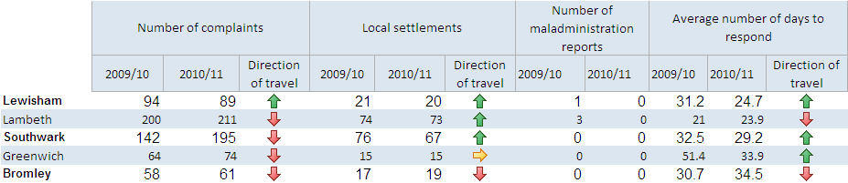
Appendix 6

Audit No. | Recommendation | Origin | Lead Person | Action taken | Target date | Status of action
2.1a | Unless a full response to a complaint can be given immediately, the complaint should be acknowledged within two working days and recorded on iCasework, in accordance with the complaints guidance procedure | Internal Audit | Jennifer Greaux – Corporate Complaints Manager | Guidance on the need to complete records to staff reissued through the corporate complaints improvement group (CCIG)  Monitoring of performance will be a regular item on the CCIG agenda | August 2011 | closed
2.1b | For quality monitoring purposes, an explanation on iCasework for not being able to meet required response dates should be mandatory | Internal Audit | Jennifer Greaux – Corporate Complaints Manager | Advice given to all users to ensure that an explanation is given in the notes field of iCasework  Corporate Complaints team will monitor relevant cases to check that these instructions are being followed. | Sept 2011 | closed
2.1c | Service areas should be reminded to record all comments, complaints and compliments to iCasework at stage one | Internal Audit | Jennifer Greaux – Corporate Complaints Manager | Highlight the importance of recording all comments, complaints and compliments to iCasework at stage one, through various mediums, such as CCIG, learning events and corporate sharepoint. Extensive training program in place. | Sept 2011 | closed
2.1d | Consideration should be given to the need to provide further training in respect of the written response to comment/complaint letters, to free them from jargon and to make them more personal and sympathetic. The emphasis should be on ensuring that the communication is responded to thoroughly to prevent potential escalation to a complaint. | Internal Audit | Jennifer Greaux – Corporate Complaints Manager | Training has been provided and will continue to be included as part of the training program and monitored through ongoing targeted quality checking | August 2011 | ongoing
3.1 | Criteria for assessing and clarifying comments and complaints should be formalised and both comment and response should consistently be recorded on iCasework | Internal Audit | Jennifer Greaux – Corporate Complaints Manager | This has been identified as part of this years annual service plan. The corporate complaints manager will work with CCIG to design and implement the framework. The draft framework will be discussed and signed off at CCIG | December  2011
4.1a | Completion of fields within iCasework should be made mandatory or level of management review and sign off stepped up to ensure that the appropriate amount of information has been recorded and appropriate action has been taken | Internal Audit | Jennifer Greaux – Corporate Complaints Manager | Follow on actions have already been discussed by the CCIG. However due to cost implications, the fields cannot be made mandatory on iCasework. Further discussions will take place within CCIG to find a workable solution | deferred | deferred
4.1b | As a positive step in showing that the Council cares and is listening, comments that have resulted in a change in policy or procedure should be actively publicised and updated | Internal Audit | Jennifer Greaux – Corporate Complaints Manager | Will be reiterated at CCIG. Emails will be sent and information included on the website. | March 2012 | ongoing
5.1 | If there continues to be a poor response, customer sent surveys should where possible be contacted by phone to determine why they have not responded to the survey form | Internal Audit | Jennifer Greaux – Corporate Complaints Manager | Analysis of the response rate will take place during 2011/2012. The effectiveness and methodology of the survey will be evaluated and fed back to CCIG. | By October 2011 | open
1 | Ensure that all officers dealing with complaints, especially those at stage one and stage two of the complaints process, include an analysis of the complaint on file: the analysis to show the key steps taken in the investigation of the complaint; the evidence used to determine it; a summary of the officer’s views of the complaint; and eventually the final outcome. | IA report 2009/2010 | All | This was discussed at CCIG and officers felt that this approach would be too labour intensive and they did not have the resource to undertake this task for each case. Therefore it was decided that the best way forward, would be to ensure that all paperwork relating to the case would be uploaded onto iCasework. | March 2012 | closed
2 | Ensure record keeping – especially on repairs – is improved, so that the Council and its partners know and can demonstrate what has been done when. | IA report 2009/2010 | LH/RB3 | All repairs are logged on Equipe’s /Rydon’s repairs data base – Planet FM. This system records all repairs completed and can easily be tracked via Planet FM as well as LBL officers, (once the permits to view have been completed). | March 2012 | open
3 | Ensure good communication across all partner bodies so that key information – on repairs, on tenancy issues or on disabilities, for example – is shared by all those who need to know and can act on such information. | IA report 2009/2010 | LH/RB3 | Apart from the official monthly internal operations team meeting between all partners of RB3, RB3 has installed weekly ‘coffee morning’ meetings to discuss relevant issues at hand, to foster better internal communications. | March 2012 | open
4 | Log all repairs and record the outcome of repair works. Such records should be retained for at least six years, in accordance with the statutory timeframe for disrepair claims. | IA report 2009/2010 | LH/RB3 | All repairs are logged on Planet FM and the records of these repairs are kept for the required six year period. | March 2012 | open
5 | Put in place consistent and user-friendly procedures for making insurance claims and consider such claims properly, following the approach used by the Council. | IA report 2009/2010 | RB3 | Information regarding insurance claims are being imparted to residents via the housing managers as well as communicated by newsletters and information in the resident handbook and will also be available on the website, when it is completed. | March 2012 | open
6 | Identify early on whether the complaint is one the Council can deal with, and if not to signpost to an appropriate alternative source of support or help | IA report 2010/2011 | All | The IA will produce FAQ’s which will assist in ensuring whether the complaint is for the Council. The website will be updated regularly with the relevant information | March 2102 | open
7 | Ensure that recommendations involving procedural changes are followed up and the IA is kept informed of improvements made as a result of stage 3 decisions; | IA report 2010/2011 | Corporate complaints officer/All | The IA protocol is under review to make more robust. | March 2012 | open
8 | Review the guidance on apologies that has been produced in previous years, based on guidance from the Scottish Public Services Ombudsman | IA report 2010/2011 | Jennifer Greaux – Corporate Complaints Manager | Provide relevant training using guidelines set out by the Scottish Public Services Ombudsman. Make use of the website and intranet. Corporate complaints policy currently under review, which will include a section on apologies | March 2012
9 | Carry out limited research on stage 2 complaints to determine if improvements in complaint handling there and better resolution have led to the decrease in stage 3 complaints this year and might do the same in the future: the research comprising contacting those who had a stage 2 complaint but did not progress it to stage 3; | IA report 2010/2011 | Jennifer Greaux – Corporate Complaints Manager | Review the stage 2 cases that did not escalate to stage 3.  Investigate the effectiveness of use of mediation in children’s and adult social care. | March 2012
10 | Explain to housing applicants the reasons for medical decisions as well as the decision itself; | IA report 2010/2011 | Karen Shaw | A meeting is planned to discuss this issue. A letter has been drafted and discussion will take place on how best to implement. | March 2012
11 | Consider how planning officers might communicate more effectively with residents about particular developments, providing a plan of action and keeping them informed of progress. | IA report 2010/2011 | Gavin Cooper -Planning Manager | The Planning Service will be shortly reviewing how we consult & communicate with residents. At present, how planning communicates is set out in the council's Statement of Community Involvement. As part of the restructure, 2 new posts of Business Improvement & Stakeholder Manager and Customer Liaison Officer have been created specifically to address Localism issues and ensure Planning Services are built around the needs of applicants, residents and other planning stakeholders. Following a discussion at Full Council we have amended our practice that everyone who attends a local meeting is notified, if necessary, of a Planning Committee. A Customer Charter is being produced. Software is also been implemented this year which will allow residents to be alerted if a planning application is made in a particular area. | March 2012
12 | Consider in private-sector leasing complaints using the dispute procedure set out in the lease. | IA report 2010/2011 | Morna London | This procedure is used when deemed appropriate. However, if and when disputes have been raised it has been found to be more effective and better value for money to use the council's own complaints procedure. | March 2012

