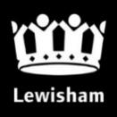
Mayor and Cabinet
Report title: Annual Complaints Report 2022-23
Date: April 2023
Key decision: No.
Class: Part 1
Ward(s) affected: All wards
Contributors: Director of Resident and Business Services; Corporate Complaints, Casework & Contracts Manager; Customer Services Manager – Environment; Head of Governance & Complaints Lewisham Homes, Quality Assurance & Business Support Manager - Adult Social Care; Complaints & Information Manager - Children’s Social Care

Outline and recommendations
The purpose of this report is to set out complaints and casework performance in 2022/23 as well as the measures being put in place to improve complaint handling, performance and service delivery.
Mayor and Cabinet are asked to note the contents and the recommendations as set out in section 2 of this report.

Outline and recommendations
The purpose of this report is to set out complaints and casework performance in 2020/21 as well as the improvement measures being put in place to improve complaint handling, performance and service delivery.
The main recommendations are under section 2 on page 3 of this report:

Timeline of engagement and decision-making
This report was reviewed by:
- The Executive Management Team 17 May 2023
- The Standards Committee on 21 June 2023

Executive Summary

Performance
Overall Council Performance for 2022/23 was 74% of complaints answered within 10 days against a target of 90% and has improved by 1% compared to last year despite a significant increase of complaints by 20%. It is also worth noting that 98% of all complaints received were completed in 11 days (just 1 day outside our target of 10 days).
Volumes
Table 1– New Stage 1’s & New Enquiries for 2022/23 for Lewisham Council
Case type (Lewisham council) | 2020/21 | 2021/22 | 2022/23 | % increase / decrease from previous year
New Complaints (Stage 1 only) | 1562 | 1923 | 2419 | 21%
All Enquires * | 4116 | 4662 | 5817 | 20%
Total | 5678 | 6585 | 8236 | 21%

*All Enquiries – This included General Enquiries, MP, Member, Mayor and CEO.

1.1 One of our core values set out in Lewisham Council’s Corporate Strategy is that ‘we are open, honest and fair in all we do’. As an organisation with a learning culture, we welcome customer feedback about its services and staff from residents and service users.
1.2 We have updated our website; making it easier for residents to make complaints, comments or suggestions on service delivery. Enquiries have increased this year due to the introduction of the members portal which allowed Cllrs to raise queries with ease and track their casework in one place.
1.3 This annual report sets out performance information on complaints and casework dealt with by Lewisham Council and its housing partners in 2022/23. The main report focuses on corporate complaints at all stages as well as enquiries to MPs, the Mayor, Councillors, and the Chief Executive and general enquiries. The Lewisham Homes annual figures have been included in this report under Appendix 14.4.

1.4 The Local Government and Social Care Ombudsman (LGSCO) report will be issued in Q3 of this year. We will publish it to the public when it is available along with our response.

1.5 The Adult Social Care and Children’s Social Care complaints reports are attached in Appendix 14.1 and 14.2 respectively. These reports include an overview of statutory complaints in Adult Social Care and Children’s Social Care.

1.6 The annual report from the Stage 3 Adjudicator can be found at Appendix 14.3.

1.7 The 2022/23 data provided in this report is based on information recorded on the complaints system - iCasework. Data for 2021/22 and previous years has been provided for comparison where available. The accuracy of the underlying data is dependent on how cases are recorded and categorised on the system by officers.

1.8 After looking at performance data, the processes around Members Casework was reviewed in partnership with a number of Councillors as part of the “Resident Experience Programme” in conjunction with the Corporate Complaints, Casework and Contracts Manager and other areas within the Council. As a result of this work, a new members portal was developed to enable elected representatives to log casework on behalf of their constituents be it a query or a complaint. This gave Councillors and Members greater visibility on the progress of their case and enable them to see who is dealing with the query. This led to improved response times for casework and cases will be directed to and owned by the service area rather than Corporate Complaints Team to prevent delays. This new portal was launched in July 2022.

Background & Main Issues
1.9 Since July 2022, performance information and response times have been available to Executive Directors, Directors and Heads of Service and therefore performance both good and bad is now being highlighted and discussed regularly in monthly Department Team meetings and quarterly at EMT and the Corporate Assurance Board.

1.10 In addition to this performance information, the Corporate Complaints team have met on a monthly basis with several teams that either have high volume of complaints and or / poor performance to better understand and support their complaints handling. These meetings have been well received and we are beginning to see better ownership and accountability around complaints performance and improved response times.

1.11 The Council recognised that investment was required in iCasework and as such invested £37k this year by renewing the contract and managing the contract more closely with the provider, Civica. This system will enable us to continue to log and track complaints and to carry out analysis of this data in helping us to improve our performance.

1.12 Table 1 – Standard Response Times & Responsibilities
Complaint / Casework | Timescales | Responsibility
Stage 1 Corporate Complaint | 10 working days | Service Manager
Stage 2 Corporate Complaint | 20 working days | Head of Service (if single service complaint)  Corporate Complaints & Casework Team (if multifaceted)
Stage 3 Corporate Complaint | 30 working days | Stage 3 Adjudicator
MP / Mayor / Councillor / CEO / General Enquiries | 10 working days | Individual Service areas unless multifaceted which is Corporate Complaints responsibility.

1.13 Since the launch of the members portal, the enterprise dashboard and enhanced reporting, we are seeing incremental improvements across all areas as the changes made bed in.

1.14 Templates have now been uploaded onto the intranet so that all staff have access to good examples of how to compile a Stage one or Stage two complaint along with the agreed escalation process.
1.15 On 27 March, the Council was served with an Enforcement Notice by the ICO (Information Commissioner’s Office) for our poor performance in responding to FOIs, specifically relating to the backlog. An action plan has been agreed with the ICO and all teams are working together to clear the historical backlog.

- Recommendations

  - One of the ways in which we have worked to improve accountability with service areas is to pilot the handling of stage 2 complaints within the respective service area. This was piloted with the Planning service in 22/23 and was successful with the service handling fewer Stage 2 complaints than the previous year.
LBL received:
46 Stage 2 complaints in 2021/22. 7 were for Planning (15%).
77 Stage 2 complaints in 2022/23. 8 were for Planning (10%)
The Planning service is a very complex service with statutory policies, planning laws and regulations, and as they successfully adopted this approach, this could be applied to less complex service areas within the Council.

  - Single service Stage Two Complaints and all Elected representative enquiries will now be responded to and dealt with by the responsible service directly and not via the Corporate Complaints team as this previously led to a delay in responses. Only multifaceted, Stage Two complaints and multifaceted elected representative enquiries are to be handled by Corporate Complaints team. This change will be rolled out across the Council in June 2023.

  - Since the members portal was implemented in July 2022 a number of system changes and enhancements have been made due to the system following feedback from Cllrs since going live. We will continue to work with Cllrs to ensure the system is catering for their needs of managing casework.

  - Complaints are also being discussed bi-monthly at the Corporate Assurance Board to focus on areas requiring improvement. The Director of Resident and Business Services attends this meeting. Improved enhanced reporting is now in place on a weekly basis which highlights all outstanding cases for service areas and the oldest cases that haven’t been responded to as well as all cases over 100 days old. From April 2023, Service Area Directors will also be expected to attend this meeting to discuss their challenges and service improvements.

  - This year as well as improving our responsiveness in dealing with complaints and enquiries, we need to continue to use the learning from complaints to address service delivery issues and to help prevent complaints arising in the first place. Each Directorate is to provide root cause analysis at the end of each financial year detailing what has been learned, what improvements they will be making within their service to increase performance and reduce complaints within their area.

  - A Complaints Handling Induction course will be developed with Learning and Development this year so that all new staff understand what is expected of them.

  - Refresher training will continue to be provided to existing staff new to using iCasework. These will be offered through group drop in sessions on a monthly basis from June 2023. This refresher training will also be extended to members who would benefit from 1-1 support.

  - The Corporate Complaints Manager and the Support and Development Team will continue to work with Civica and Lewisham Homes to ensure reporting post October 2023 when Lewisham Homes transfer to LBL will mirror current reporting

  - A documented escalation process will be put into place from June 2023 where cases not responded to on time will be escalated to the Executive Directors / Chief Executive.

Policy Context
Corporate Complaints
3.1 The Council’s Corporate Complaints Policy details how we handle the complaints and feedback that we receive. Corporate complaints are dealt with under a three stage complaints process. The Local Government & Social Care Ombudsman and Housing Ombudsman Service are external regulators with statutory powers to investigate complaints against councils.

Adult Social Care Statutory Complaints

  - Since 1991, the National Health Service and Community Care Act 1990 has charged each local authority with maintaining a statutory complaints process for adult social care services. The current regulations, The Local Authority Social Services and National Health Service Complaints (England) Regulations 2009, came into force on 1 April 2009. Statutorily, local provision of the regulations is the responsibility of each council’s Chief Executive Officer. In Lewisham, that responsibility has been delegated to the Director of Operations for Adult Social Care.

Children’s Social Care Statutory Complaints

3.3 The Children’s Act 1989 Representation Procedure (England) Regulations 2006 requires local authorities have a formal complaint handling procedure in place for children and young people who wish to make a representation or complaint about social care. The regulations set out three stages: Stage One – Local Resolution; Stage Two – Independent Investigation, and Stage three – Review Panel:

Children’s Act only complaints
3.4 The Council received a total of 98 cases of complaints in 2022/23, which were categorised under the Children’s Act. The Children’s Act complaints procedure is a statutory procedure for children and young people to make complaints and any other representations about actions and decisions of Children’s Social Care services; it is also open to any other person acting on their behalf, as well as to people with ‘sufficient interest’ in the child or young person, to make complaints in their own right.

3.5 There was an increase of 13 cases on previous year 21/22 when 85 were received. There is a direct link with the higher number of complaints received and an increase in demand for services. There was a 29% increase in the number of referrals into Children’s Social Care during the period (3381 in 2020/21 and 4365 in 2021/22) this together with a number of vacancies, has resulted in significant pressure on the service and the timeliness/quality of our communication which is our most reoccurring theme.

CYP Stage 1: Statutory complaints | 2021/22 | 2022/23 | % change
Statutory Stage 1 complaints | 85 | 98 | 13%

Top three 2022/23 Children Act Complaints:

MASH / Referral and Assessment 30
Corporate Parenting 28
Family Support and Safeguarding 23

Overall Complaints within Children Young People section.

All CYP stage 1 complaints | 2021/22 | 2022/23 | % change
Statutory Stage 1 Complaints | 85 | 98 | 13%
Non Statutory Stage 1 Complaint | 53 | 73 | 28%
Total | 138 | 171 | 20%

3.6 Children’s Act complaints are about children’s social care only and are prescribed by the Children’s Act regulations. Non Statutory complaints are complaints falling under the Council’s corporate complaints procedure, which for CYP includes complaints about educational services – admissions, Special Education Needs and Disabilities (SEND).

Top three 2021/22 All stage 1 complaints:
Integrated Services & SEND 52
MASH / Referral and Assessment 27
Family Support and Safeguarding 23

- Council Wide Overall Performance

Table 2 – Volume of New Stage 1 Corporate Complaints Received by Lewisham Council & Lewisham Homes
 | Stage 1 Corporate Complaints Received – Lewisham Council & Lewisham Homes
Organisation |  | 2020/21 | 2021/22 | 2022/23 | % increase / decrease from previous year
Lewisham Council |  | 1926 | 1923 | 2421 | 21%
Lewisham Homes |  | 381 | 680 | 1192 | 43%
Total |  | 2307 | 2667 | 3613 | 36%

Comparison with 2021/22 shows that complaints and enquiries have increased over 2022/23 by 21%, however despite the increase, performance has improved over the year. See table 2 below which provides comparison of stage 1 (new) complaints and Enquiries from 2019/20, 2020/21 and 2021/22.

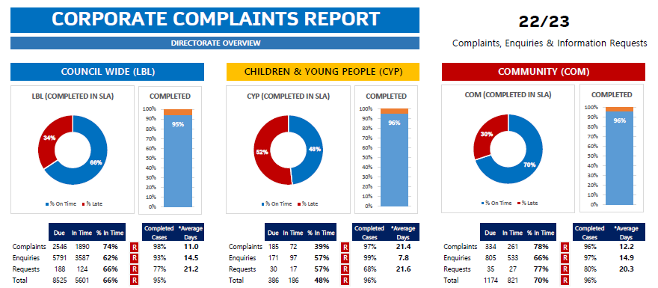

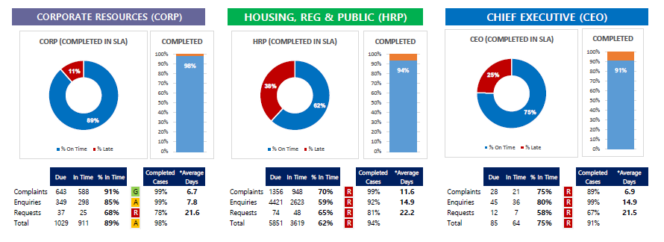

4.1 Overall Performance for the Council is under section 1. Individual Directorate performance is below:

CYP Division
39% of complaints responded to on time compared to 43% in 21/22
57% of enquiries responded to on time compared to 45% in 21/22
57% of requests responded on time compared to 45% in 21/22

Community Division
78% of complaints responded to on time compared to 56% in 21/22
66% of enquiries responded to on time compared to 86% in 21/22
77% of requests responded on time compared to 49% in 21/22

Corporate Resources
91% of complaints responded to on time compared to 95% in 21/22
86% of enquiries responded to on time compared to 86% in 21/22
68% of requests responded on time compared to 45% in 21/22

HRPR
70% of complaints responded to on time compared to 69% in 21/22
59% of enquiries responded to on time compared to 79% in 21/22
65% of requests responded on time compared to 50% in 21/22

CEO
75% of complaints responded to on time compared to 56% in 21/22
80% of enquiries responded to on time compared to 86% in 21/22
58% of requests responded on time compared to 48% in 21/22

See table 2 below which provides comparison

Lewisham Council & Lewisham Homes.

    - The total number of new complaints and enquiries received by Lewisham Council and Lewisham Homes in 2022/23 was 8,931 compared to 8,337 cases in 2021/22.

    - Of the 2,421 new Stage 1 complaints received in 2022/23, only 77 complaints (3%) escalated to Stage 2; 54 complaints escalated to Stage 3; and 8 (council only) cases referred to the Local Government & Social Care Ombudsman (LGSCO).

4.3 The volume of overall complaints & Enquiries increased from the previous year with an increase of 7% (594) from 8,337 in 21/22 to 8,931 in 22/23.

4.4 New first stage complaints (3,613) accounted for just over 40% of all casework received in 2022/23.

4.5 There were 7,058 new enquiries received in 2022/23. 24% of these cases were general enquiries, 23% were Member/Cllr enquiries and the remainder were MP / Mayor / CEO enquiries. The nature of general enquiries varies but can include a request for a service or advice and information. There was also a significant increase in the number of Cllr enquiries due to the introduction of the Members portal in July 22.

Table 3 – Volume of New Enquiries by Lewisham Council & Lewisham Homes
 |  | Enquiries Received – Lewisham Council & Lewisham Homes
Organisation | 2020/21 |  | 2021/22 | 2022/23 | % increase / decrease from previous year
Lewisham Council | 4492 |  | 4,662 | 5,817 | 24%
Lewisham Homes | 1069 |  | 1,376 | 1,241 | -10%
Total | 5561 |  | 6,038 | 7,058 | 16%

4.7 The direction of travel shows a 16% increase of enquiries compared to last year.

Table 4 – Volume of Complaints & Enquiries Received (Lewisham Council & Lewisham Homes)

Summary – Case Volumes

4.8 Overall there is an increase in complaints and enquiries compared to last year. The direction of travel above for the Council shows a 20% increase overall for Stage 1 complaints when compared to last year and Lewisham Homes has seen a significant increase in the number of complaints (75%). This increase has been seen across the social housing sector for this period. Overall across this equates to a 36% increase in Stage 1 complaints.

Root cause of complaints

5.1 See below for top 10 service areas which received the most complaints. The services are high volume contact areas for the council, for areas such as waste collection, council tax, Housing and Planning.
Revenues issue 130,000 Council tax notices to domestic properties. With 437 complaints for 22/23 this equates to less than 0.0033% residents being dissatisfied with the service
It is worth noting that Environmental service collects 330,000 bins a week and 363 complaints equates to the service failing on 0.0001% of occasions
The total number of PCNs issued for last year is 207,162. 129 complaints received for the same period equates to 0.0622% of motorists either dissatisfied with the service or the parking/ moving traffic enforcement policy

Table – 5 – Top Ten Complaints by Service Areas
Top 10 | Service Areas | Cases |  | % upheld
1 | Council Tax | 437 |  | 13%
2 | Waste | 363 |  | 60%
3 | Parking Services - General | 129 |  | 16%
4 | Refuse & Recycling | 123 |  | 33%
5 | Homelessness Prevention & Assessment Service | 96 |  | 34%
6 | Housing Benefit | 92 |  | 1%
7 | Parks & Open Spaces | 82 |  | 23%
8 | Cleansing | 68 |  | 15%
9 | Supply & Resettlement- TA and Procurement of Properties | 57 |  | 26%
10 | Housing Options Centre | 48 |  | 29%

Table 5.1 – Top 10 Complaints – Council Tax
Rank | Council Tax | Case
1 | Account Query | 257
2 | Liability dispute | 44
3 | Refunds | 29
4 | Discount/exemption | 21
5 | Summons | 15
6 | Customer Service | 15
7 | Payments | 11
8 | Telephone | 10
9 | Enforcement Agents | 9
10 | Notices Issued (Rem/Final) | 8

Table 5.2 – Top 10 Complaints – Waste
Rank | Waste | Case
1 | Refuse | 126
2 | Recycling | 114
3 | Missed collections | 102
4 | Resources & Regeneration | 8
5 | Lumber collections | 4
6 | No classification | 3
7 | Mattress collection | 3
8 | Reuse and Recycling Centre (CA site) | 2
9 | Clean streets | 1
10

Table 5.3 – Top 10 Complaints – Parking General
Rank | Parking General | Case
1 | PCNs | 69
2 | Parking Permits | 16
3 | Parking Enforcement | 14
4 | Parking signs and lines (existing) | 7
5 | Pay and Display | 6
6 | No Classification | 5
7 | NSL (Contractor) | 5
8 | Moving traffic enforcement | 3
9 | Resources & Regeneration | 2
10 | Parking Designs | 1

Table 5.4 – Top 10 Complaints – Refuse & Recycling

Rank | Refuse & Recycling | Case
1 | Missed Collection | 62
2 | Request for new/replacement bin | 25
3 | Disposal | 13
4 | Broken Bin | 12
5 | Bin not returned | 7
6 | Resources & Regeneration | 2
7 | Contamination | 2
8
9
10

Table 5.5 – Top 10 Complaints – Homelessness & Assessment Services
Rank | Homelessness Prevention & Assessment Service | Case
1 | Housing Options Centre service (frontline) | 35
2 | Temporary Accommodation | 22
3 | Homeless/ Part 7 application | 11
4 | Suitability of accommodation | 7
5 | Eviction | 6
6 | Temporary accommodation (PSL) | 4
7 | Temporary accommodation (hostel) | 3
8 | Housing register /Part 6 application | 3
9 | Temporary Accommodation (Nightly Paid) | 1
10 | Change in circumstances | 1

5.3 . See below for further information on each of the top 5 Services, which show specific areas within the service that customer have made a complaint about.

5.3 Following the launch of our Chatbot last year onto the LBL webpage, we are reviewing our online offer so that we better improve the customer experience and reduce the number of incoming calls to the Call Centre regarding council tax enquiries.

5.4 We also plan to review our council tax letters over the course of this year so that we can offer better support and information for residents.

Table 6 – Top 5 Complaint Issues & Outcomes
Outcome of Top 5 Complaint Issues in 2022/23
Lewisham Council
Complaints Issue | No. of Cases | Resolved upon Receipt | Not Upheld | Partly Upheld | Upheld (%)
Account Query (Council Tax) | 257 | 11 | 177 | 33 | 36 (14%)
Refuse (Waste) | 126 | 19 | 20 | 16 | 71 (56%)
Recycling (Waste) | 114 | 21 | 12 | 27 | 54 (23%)
Missed Collections (Waste) | 102 | 5 | 11 | 3 | 83 (81%)
PCN’s (Parking General Services) | 69 | 9 | 41 | 4 | 15 (21%)
Lewisham Homes
Complaints Issue | No. of Cases
Plumbing | 70
Operational Issues | 46
Appointments | 36
Neighbour nuisance | 34
Damp | 30

Table 6.1 – Additional information supplied by Lewisham Homes.
Outcome | 2022/23
Upheld | 41%
Not upheld | 29%
Partly upheld | 29%

6. Performance (Cases Due & Timelines)

6.1 Please see below for summary of Lewisham council performance in Table 7, please see table 8 for more granular information including Lewisham homes.

Table 7 – Lewisham council overall complaints and Enquiries performance.
LEWISHAM Timeliness of Corporate Complaints & All Enquiries
Organisation | Year / Variance | Stage 1 & 2 Complaints |  | All Enquiries
 |  | Cases Due | % On Time | Cases Due | % On Time
Lewisham Council | 2020/21 | 1612 | 77% | 4116 | 86%
 | 2021/22 | 1976 | 73% | 4662 | 78%
 | 2022/23 | 2496 | 74% | 5817 | 64%

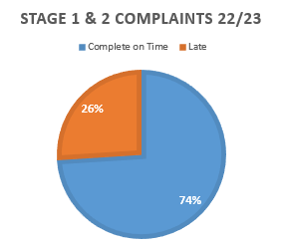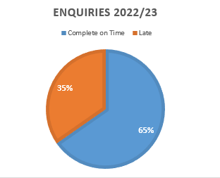

Table 8 - Timeliness of Stage 1 & Stage 2 Corporate Complaints and General Enquiries –Lewisham Council & Lewisham Homes, exc. Statutory complaints for children’s and adult’s social care

Timeliness of Corporate Complaints and General Enquiries – Council Directorates & Lewisham Homes
Organisation | Year / Variance | Stage 1 Complaints |  | Stage 2 Complaints |  | General Enquiries
 |  | Cases Due | % On Time | Cases Due | % On Time | Cases Due | % On Time
Lewisham Council | 2020/21 | 1562 | 79% | 50 | 28% | 2422 | 98%
 | 2021/22 | 1923 | 73% | 53 | 72% | 4662 | 78%
 | 2022/23 | 2419 | 75% | 77 | 44% | 5817 | 63%
 | Variance | 496 | 2% | 24 | 28% | 1,155 | 15%
Lewisham Homes | 2020/21 | 331 | 91% | 90 | 92% | 274 | 84%
 | 2021/22 | 680 | 76% | 174 | 69% | 215 | 78%
 | 2022/23 | 1192 | 83% | 331 | 79% | 1254 | 75%
 | Variance | 512 | 7% | 157 | 10% | 1039 | 3%
Total | 2020/21 | 1893 | 81% | 140 | 69% | 2696 | 97%
 | 2021/22 | 2603 | 74% | 227 | 70% | 2210 | 96%
 | 2022/23 | 3611 | 77% | 414 | 71% | 7071 | 65%
 | Variance | 1008 | 3% | 187 | 1% | 4861 | 31%

6.2 The number of Stage 1 complaints saw an increase this year of 1,008 from 2021/22. Despite this significant increase in volumes, performance has increased by 3% on previous year.

This increase in cases is also reflected in stage 2 volumes which increased by 187 on previous year, however performance increased by 1% – see section 2.2.

6.3 Whilst general enquiries performance has reduced by 15%, this is due to the significant increase of cases logged by almost 1,155 compared to the previous year and is the bulk of the overall volume of all casework and complaints. This huge increase in volumes (25%) is down to the introduction of the Members Casework portal in July 22 where all members casework is now logged. In previous years, members casework wasn’t logged on the Councils database.

6.4 Completion rates of all casework is extremely high with 98% of all complaints being answered within 11 days and 93% of all enquiries being answered within 14.5 days.

Performance
6.5 A significant improvement has been made over the last year with the introduction of the Members Portal with 96% of all members enquiries now handled via the portal.

6.6 Overall volumes across all elected representative enquiries has increased. Performance has increased by 2% on MP enquiries despite the small increase in volumes of 79. Performance has decreased by 2% compared to last year for Mayor enquiries, a reduction of 17% performance for Members enquiries and a 12% reduction in performance for Chief Exec enquiries compared to last year. However it must be noted that even though performance has dropped, since the introduction of the members portal, the number of enquiries overall has increased by over 2,000 compared to the previous year and all of those additional enquiries were from members using the new portal. This is likely to further increase this year as the portal was only introduced part way through the 2022/23 year. Better reporting measures have been put in place to monitor performance monthly and therefore any reduction in performance will continue to be picked up and addressed in a timely fashion.

7 Complaint outcomes

7.1 The high level breakdown of complaints by decision in 2022/23 for Lewisham Council and Lewisham Homes is as follows:

Table 10 – Complaints Outcomes in 2022/23 – (Lewisham Council & Lewisham Homes)
Complaint Outcomes – Lewisham Council*
Complaint Stage | Resolved at initial contact | Withdrawn | Not Upheld | Partly Upheld | Upheld | Total
Stage 1 | 453 (22) | 0 | 904(77) | 394 (42) | 584 (24) | 2335 (165)
Stage 2 | 0 | 5 | 49 (5) | 12 (3) | 10 (0) | 77 (8)
Stage 3 | 0 | 0 | 37 (0) | 9 (0) | 7 (0) | 53(0)
Total | 453 | 5 | 990 (83) | 415 (45) | 601 (25) | 2464 (173)
% of Total | 18% | 0.2% | 40% | 17% | 24% | -
CONTAINS CYP & ASC STATUTORY CASES AT ALL STAGES (in brackets)*.

7.2 41% (38% 21/22) of all complaint cases handled in Lewisham were upheld or partly upheld. The breakdown by complaint stage was as follows:
- Stage 1 –42% (39% 21/22) partly upheld/upheld;
- Stage 2 – 29% (32% 21/22) partly upheld/upheld;
- Stage 3 – 30% (37% 21/22) partly upheld/upheld.

8. Local Government and Social Care Ombudsman Annual Letter 2022/23

8.1 At the time of writing, the ombudsman’s letter is not yet available but we will publish it on our website, alongside our response as soon as we receive of it.

9 Stage 3 Adjudicator

9.1 The Stage 3 Adjudicator deals with Stage 3 complaints on behalf of the Council, Regenter and Lewisham Homes.

9.2 The Stage3 Adjudicator report for the Council is attached at below at Appendix 8.3. The key headlines are:

- 145 cases were received and 63% of these cases were regarding housing providers (Lewisham Homes and Regenter B3);
- The S3A determined 54 cases about the Council. The top themes for the Council were housing and homelessness. The top themes for housing providers were repairs and major works;
- Compensation was awarded in 52 cases totalling £30,699.23;
- The average compensation awarded was £590 in 2022/23, which a 20% increase on the previous year (£494). The median payment was £500 and the most frequent £500.
- Just over half of the complaints (76 out of 145, 52%) were upheld or partly upheld at stage 3.

Stage 3 Adjudicator Case Outcomes and Average Compensation Payment
Year | Cases  Determined | Cases Upheld / Partly Upheld | Cases Awarded Compensation | Total Compensation Awarded | Average Compensation Awarded
2021/22 | 109 | 57 | 50 | £24,732 | £494
2022/23 | 145 | 76 | 52 | £30,699 | £590

9.3 The large increase in compensation paid this year reflects the greater impact of fault on more vulnerable residents, particularly delays in completing housing repairs.
- The S3A uses LGSCO and HOS guidance on remedies to arrive at compensation figures. There were cases this year which required significant payment to comply with that guidance, and even then, the ombudsmen recommended an additional payment in 4 cases, one of which might otherwise have ended up in court.

10 Complaints and enquiries by ward

10.1 Number of case records: 1,563
Of these:
- Number of records where postcodes are in Lewisham: 844
- Number of records where postcode is missing: 653
- Number of records where postcode is incomplete: 33
- Number of records where postcode is outside Lewisham: 32
- Number of records where postcode is “HOMELESS”: 1

10.2 Summary tables
Note: the data does not explicitly mark cases as complaints or inquiries. In this analysis, all cases handled by the Corporate Complaints Team are considered to be complaints, and all other cases are considered enquiries.
By number of cases:
Ward | Complaint | Enquiry | Total
Rushey Green | 31 | 176 | 207
Crofton Park | 23 | 39 | 62
Lee Green | 9 | 51 | 60
Sydenham | 10 | 40 | 50
Blackheath | 7 | 43 | 50
Telegraph Hill | 13 | 34 | 47
Forest Hill | 14 | 30 | 44
Catford South | 13 | 27 | 40
Brockley | 4 | 34 | 38
New Cross Gate | 6 | 31 | 37
Deptford | 11 | 24 | 35
Ladywell | 6 | 29 | 35
Hither Green | 8 | 23 | 31
Perry Vale | 7 | 22 | 29
Downham | 6 | 14 | 20
Grove Park | 3 | 14 | 17
Lewisham Central | 2 | 14 | 16
Bellingham | 4 | 12 | 16
Evelyn | 0 | 10 | 10

Number of cases per 1,000 residents:
Ward | Complaint | Enquiry | Total
Rushey Green | 1.63 | 9.25 | 10.88
Crofton Park | 1.49 | 2.53 | 4.02
Lee Green | 0.60 | 3.40 | 4.00
Sydenham | 0.59 | 2.36 | 2.95
Blackheath | 0.43 | 2.62 | 3.04
Telegraph Hill | 0.77 | 2.01 | 2.78
Forest Hill | 0.92 | 1.98 | 2.90
Catford South | 0.75 | 1.56 | 2.32
Brockley | 0.23 | 1.94 | 2.17
New Cross Gate | 0.54 | 2.80 | 3.34
Deptford | 0.65 | 1.41 | 2.06
Ladywell | 0.39 | 1.86 | 2.25
Hither Green | 0.40 | 1.14 | 1.54
Perry Vale | 0.38 | 1.18 | 1.55
Downham | 0.33 | 0.76 | 1.09
Grove Park | 0.19 | 0.89 | 1.08
Lewisham Central | 0.24 | 1.71 | 1.95
Bellingham | 0.34 | 1.03 | 1.37
Evelyn | 0.00 | 0.69 | 0.69

10.3 Analysis

The distribution of complaints and enquiries received by ward per 1,000 residents in 2022/23 is shown below.
The below information is based on available postcode data. In 2022/23 1,563 complaints and enquiries were recorded (compared with 8,006 in 2021/22) and ward information was available for 844 of these (compared with 6,597 in 2021/22). 653 records did not have a postcode recorded and 33 records had incomplete postcodes. The remaining 33 complaints and enquiries were made by residents outside of London (32) and a postcode recorded as ‘homeless’ (1). The majority of records with no postcode information recorded were enquiries (584 of 1,251 enquiries, 46% of enquiries) compared to 43% of complaints (135 of 312 complaints).

Complaints and enquiries per 1,000 by ward received in 2022/23 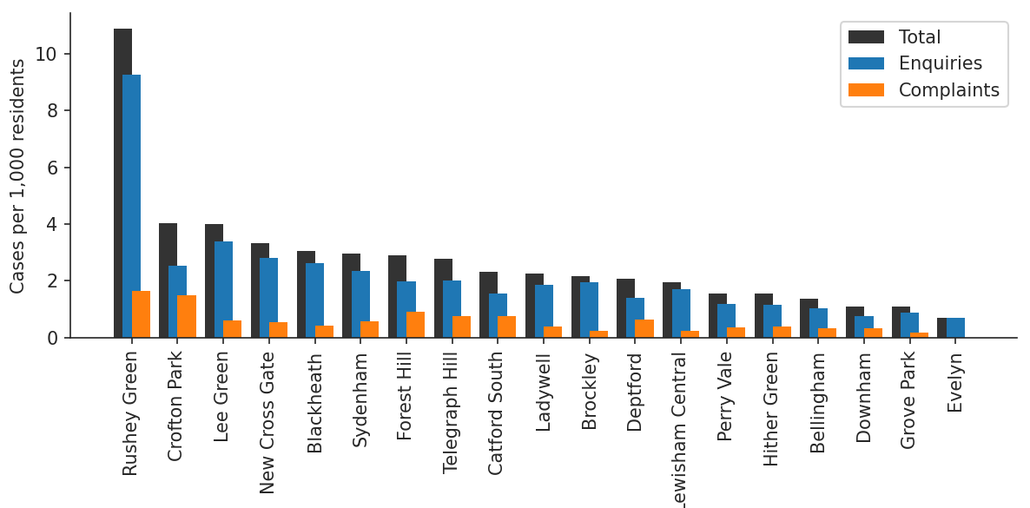
10.4 In 2022/23, the highest number of complaints received per 1,000 residents were from residents in Rushey Green (1.6 complaints per 1,000). In 2021/22, the highest number of complaints received per 1,000 residents were from residents in Evelyn (9.9 complaints per 1,000). The lowest number of complaints per 1,000 residents were from residents in Grove Park (0.2 complaints per 1,000). There were no complaints from Evelyn ward. In 2021/22, the lowest number of complaints received per 1,000 residents were from residents in Rushey Green and Whitefoot (with 4.1 complaints per 1,000 residents in both wards). In 2022/23, there were an average of 0.6 complaints per 1,000 compared to 6.9 complaints in 2021/22; part of the reason for this increase is due to improved postcode recording meaning that ward information is available for more complaints.
Number of cases per 1,000 residents, Complaints only:
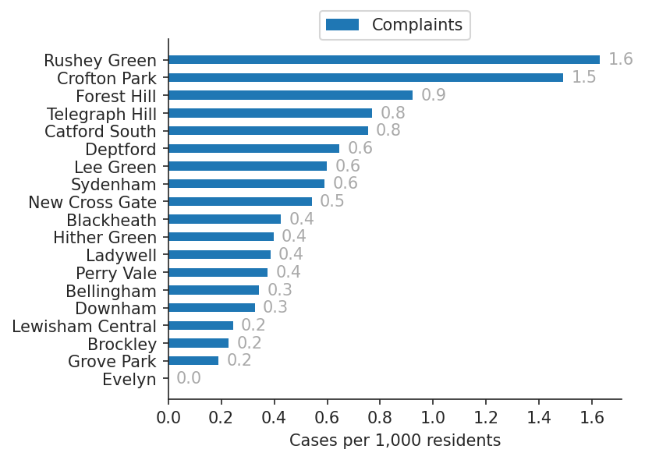
10.5 The highest number of enquiries received per 1,000 residents were from residents in Rushey Green (9.3 enquiries per 1,000 in 2022/23), and Lee Green (3.4 enquiries per 1,000 in 2022/23). In 2021/22, the highest number of enquiries received per 1,000 residents were from residents in Brockley (45.3 complaints per 1,000) and Ladywell (39.8 enquiries per 1,000). The lowest number of enquiries per 1,000 residents was in Evelyn (0.7 enquiries per 1,000 in 2022/23). In 2021/22, the lowest number of enquiries per 1,000 residents was in Downham (5.9 enquiries per 1,000 in 2021/22). The average number of enquiries per 1,000 residents in each ward was 2.2 in 2022/23 (compared with 14.5 in 2021/22).

Number of cases per 1,000 residents, Enquiries only:
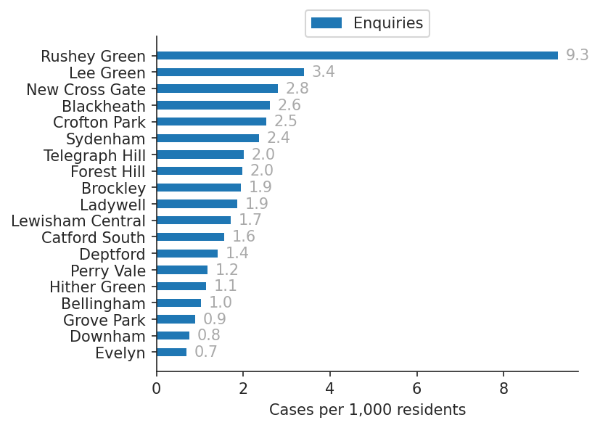
10.6 Of the 31 complaints made by residents of Rushey Green in 2022/23, Traffic management was the most complained about service (5 complaints), followed by Refuse & Recycling (4 complaints) and Highway Maintenance (4 complaints). In the ward with the least complaints per 1,000 residents, Grove Park, the most commonly complained about service was Refuse & Recycling (1 complaint in 2022/23) and Traffic management (1 complaint).
10.7 In Rushey Green, the ward with the most enquiries, 18.8% of enquiries related to Waste (33 enquiries in 2022/23). The second most common service to be the subject of an enquiry from a resident was Cleansing, with 12 enquires or 6.8% of the total enquiries from residents in Rushey Green. In Lee Green, the ward with the second most enquiries, the majority related to Parking Services (25.5% and 13 enquiries in 2022/23) followed by Council Tax (11.8% and 6 enquiries in 2022/23).
10.8 Finally, residents in Evelyn made the fewest enquiries in 2022/23 (0.7 per 1,000) and the largest proportion of these related to the Housing Register & Allocations/ Homesearch (20% and 2 enquiries), followed by Council Tax (10% and 1 enquiry) and Housing Benefit (10% and 1 enquiry).

11. Equalities Analysis

11.1 The Council has the ability to collect equalities monitoring information on the iCasework system. This information is not mandatory but it can help the Council to review the complaints process and to ensure that it remains accessible and to everyone.

11.2 The equalities data presented below is based on 10,077 contact records. In most of these contact records the equalities information was not disclosed. Therefore the equalities breakdown provided in the tables below gives us an indication of the diverse characteristics of complainants or service users in 2022/23. However, we cannot assume that this is an equalized profile of all complainants and service users during this period of time.

11.3 Almost 42% of contacts did not provide gender information. Of those who did respond, there were nearly twice as many female persons compared to male persons. This may be disproportionately higher because of the way case contacts are recorded on the system.

Table 1 – Equalities Data – Gender
Total for Gender is 10,077 for 01/04/2022 – 31/03/2023 (does not include Lewisham Homes)
Equality Category | Equality Characteristics | As % of Total Contacts | 01/04/2021 to 31/03/2022
Gender | Did not disclose | 39% | 57%
 | Female | 36% | 28%
 | Male | 22% | 14%
 | Prefer not to say | 3% | 1%
 | Transgender | 0% | 0%
 | Total | 100% | 100%

11.4 98% of contacts did not disclose whether they had a disability or not. The remaining 2% of contacts disclosed details of the type of disability or impairment affecting them.

Table 2 – Equalities Data – Disability
Total for Disabilities is 10,077 for 01/04/2022 – 31/03/2023 (does not include Lewisham Homes)
Equality Category | Equality Characteristics | As % of Total Contacts | 01/04/2021 to 31/03/2022
Disability | Did not disclose or No Disability | 98% | 97%
 | Disability / Any Other Disability or Impairment | 2% | 3%
 | Physical Impairment | 0% | 0%
 | Mobility Issues | 0% | 0%
 | Mental Health Condition | 0% | 0%
 | Social or Communication Impairment | 0% | 0%
 | Long Standing Illness | 0% | 0%
 | Total | 100% | 100%

11.5 Although 77% of contacts did not disclose their sexual orientation, of the remaining 23% of contact, 939 of the respondents preferred not to say (9%) and almost 1,356 disclosed a heterosexual orientation (13%).

Table 3 – Equalities Data – Sexual Orientation
Total for Sexual Orientation is 10,077 for 01/04/2022 – 31/03/2023 (does not include Lewisham Homes)
Equality Category | Equality Characteristics | As % of Total Contacts | 01/04/2021 to 31/03/2022
Sexual Orientation | Did not Disclose | 77% | 70%
 | Prefer not to say | 9% | 19%
 | Heterosexual | 13% | 10%
 | Gay / Lesbian | 1% | 1%
 | Bisexual | 0% | 0%
 | Total | 100% | 100%

11.6 Our ethnicity data indicate 70% of those contacting us did not provide ethnicity details and of the remaining 30%, a large proportion of the responses were from the Bangladeshi community. We looked into this anomaly as our 2021 census data tells us that this community only make up 1% of Lewisham’s population and have identified a recording error on our system. This issue has subsequently been reported to our software provider and a fix has been applied. Unfortunately we cannot retrospectively capture the ethnicity data.
.

Table 4 - Equalities Data – Ethnicity
Total for Ethnicity is 10,077 for 01/04/2022 – 31/03/2023 (does not include Lewisham Homes)
Equality Category | Equality Characteristics | As % of Total Contacts | 01/04/2021 to 31/03/2022
Ethnicity | Did not disclose | 70% | 79%
 | Bangladeshi | 10% | 7%
 | Prefer not to say | 3% | 7%
 | White Other | 2% | 2%
 | Caribbean | 2% | 2%
 | African | 1% | 1%
 | Black or Black British Other | 1% | 1%
 | Other | <1% | 1%
 | White and Black Caribbean | <1% | 0%
 | Any other mixed background | <1% | 0%
 | Indian | <1% | 0%
 | Asian or Asian British Other | <1% | 0%
 | White and Black African | <1% | 0%
 | Chinese | <1% | 0%
 | Turkish | <1% | 0%
 | Any other groups | <1% | 0%
 | Pakistani | <1% | 0%
 | White and Asian | <1% | 0%
 | Eastern European | 0% | 0%
 | Traveller or Roma | 0% | 0%
 | Total | 100% | 100%

11.7 75% of contacts did not provide their age data. Of the remaining 25%, more than half of the contacts were from people aged 25 – 54 years (62%).

Table 5 – Equalities Data – Age Band
Total for Age Group is 10,077 for 01/04/2022 – 31/03/2023 (does not include Lewisham Homes
Equality Category | Equality Characteristics | As % of Total Contacts | 01/04/2021 to 31/03/2022
Age Band | Did not Disclose | 75% | 80%
 | 0 – 14 years old | <1% | <1%
 | 15 – 24 years old | 1% | <1%
 | 25 – 54 years old | 16% | 13%
 | 55 – 64 years old | 4% | 3%
 | 65+ years old | 3% | 3%
 | Total | 100% | 100%

11.8 Equalities implications
Equalities data for 2021/22 is provided in Section 7 of this report. The iCasework system enables the Council to collect equalities monitoring information and it is used to help ensure the complaints process remains accessible and that no particular parts of the community suffer inequity in service delivery.

12 Financial Implications

12.1 There are no direct financial implications arising from this report. The Council has no specific budgets for compensation payments so the costs are absorbed by the relevant service as awarded

13 Legal Implications

13.1 There are no specific legal implications directly arising from this report aside from noting that it is recommended good practice from the Local Government’s Ombudsman’s Office to make full and specific reference to handling complaints within a management agreement entered into under section 27 of the Housing Act 1985.

13.2 Given the subject and nature of this report, it is relevant here to note that the Equality Act 2010 (the Act) introduced a new public sector equality duty (the equality duty or the duty). It covers the following nine protected characteristics: age, disability, gender reassignment, marriage and civil partnership, pregnancy and maternity, race, religion or belief, sex and sexual orientation.

13.3 In summary, the Council must, in the exercise of its functions, have due regard to the need to:
- eliminate unlawful discrimination, harassment and victimisation and other conduct prohibited by the Act;
- advance equality of opportunity between people who share a protected characteristic and those who do not;
- Foster good relations between people who share a protected characteristic and those who do not.
13.4 The duty continues to be a “have regard duty”, and the weight to be attached to it is a matter for the Mayor, bearing in mind the issues of relevance and proportionality. It is not an absolute requirement to eliminate unlawful discrimination, advance equality of opportunity or foster good relations.

13.5 The Equality and Human Rights Commission has recently issued Technical Guidance on the Public Sector Equality Duty and statutory guidance entitled “Equality Act 2010 Services, Public Functions & Associations Statutory Code of Practice”. The Council must have regard to the statutory code in so far as it relates to the duty and attention is drawn to Chapter 11 which deals particularly with the equality duty. The Technical Guidance also covers what public authorities should do to meet the duty. This includes steps that are legally required, as well as recommended actions. The guidance does not have statutory force but nonetheless regard should be had to it, as failure to do so without compelling reason would be of evidential value. The statutory code and the technical guidance can be found at:

http://www.equalityhumanrights.com/legal-and-policy/equality-act/equality-act-codes-of-practice-and-technical-guidance/ The Equality and Human Rights Commission (EHRC) has previously issued five guides
- The essential guide to the public sector equality duty
- Meeting the equality duty in policy and decision-making
- Engagement and the equality duty
- Equality objectives and the equality duty
- Equality information and the equality duty
13.6 The essential guide provides an overview of the equality duty requirements including the general equality duty, the specific duties and whom they apply to. It covers what public authorities should do to meet the duty including steps that are legally required, as well as recommended actions. The other four documents provide more detailed guidance on key areas and advice on good practice. Further information/resources are available at:
http://www.equalityhumanrights.com/advice-and-guidance/public-sector-equality-duty/guidance-on-the-equality-duty/

Term | Definition
IA | Stage 3 Adjudicator
LGSCO | Local Government & Social Care Ombudsman
HO | Housing Ombudsman

Appendices
14.1 Adult Social Care Annual Complaints Report (2022/23)
14.2 Children’ Social Care Annual Complaints Report (2022/23)
14.3 Independent Adjudicator Annual Report (2023/23)
14.4 Lewisham Homes Annual Report (2022/23)

Report author and contact

Lew McKenzie, Complaints & Casework Manager, lew.mckenzie@lewisham.gov.uk
Comments for and on behalf of the Executive Director for Corporate Resources,
Kathy Freeman, Kathy.Freeman@lewisham.gov.uk
Comments for and on behalf of the Director of Law, Governance and HR,
Jeremy Chamber, Principal Lawyer, Jeremy.Chambers@lewisham.gov.uk

